PREVIEW: Full-Wave Electromagnetic Simulation Applications

Who should read this book
This book is for readers without a strong background in electromagnetic simulation who want to gain insight in this field. Maybe you are an engineer in a different field of expertise, and you are curious about the topics that colleagues in electromagnetic simulation work on. Maybe you are an engineer who is asked to help out in electromagnetic applications, while this field feels alien and uncomfortable to you. Maybe you are a student who has to simulate a few devices but misses the overview. The book’s aim is to provide insights into applications, and give a good physical understanding of phenomena and of why devices work the way they do.
Equations will be used in the book, but in such a way that you can skip them if you want. Also, text in smaller font can be skipped without losing track of the main explanation. The regular text and illustrations will always provide enough explanation for a good understanding of the topic that is being discussed.
This book is not a textbook. Textbooks are meant for study; this book is meant for reading. Still, the book contains a lot of information. It has been written in such a way that you can choose to read just the sections in which you are interested.

About the author
Martin Vogel studied Physics in the Netherlands. He has spent his professional career in roles in which electromagnetic simulation had a central place. His first job was at TNO Defense and Security in the Netherlands. There, he created a model to simulate the performance of proximity fuses in defensive missiles. To determine what the proximity fuse “sees”, he developed his own physical-optics code. The aspects of close proximity and moving targets were new, and he used the research to obtain a PhD, while being employed at TNO. Later research focused on radar cross section (including development of aspects of a finite-element code), and propagation of radar signals over sea (including development of a parabolic-equation solver to simulate atmospheric ducting).
TNO enabled him to work for one year at the Air Force Research Laboratory in New Mexico, USA, on aspects of high-power microwave weapons. He improved an ultra-wideband antenna using the Method-of-Moments-based code NEC. During this year, he met his soon-to-be wife, an American physicist who worked on electromagnetic applications for a defense contractor, at a conference.
He and his wife joined Ansoft in Pennsylvania in the USA, she as a software developer for Ansoft’s flagship product HFSS (High-Frequency Structure Simulator, a finite-element-based full-wave electromagnetic simulation tool) and a few other tools, and he as an application engineer for HFSS and a few other tools. Ansoft was acquired by Ansys (a company with many physics-based simulation tools) in 2008. He and his wife left Ansys in 2011. Ansys was acquired by Synopsys in 2024.
In 2012, he and his wife enjoyed a sabbatical in Costa Rica, in a green hilly area with, thanks to elevation, a perfect moderate climate and many coffee farms.
After this, they joined EMSS and EMSS-USA in Virginia in the USA, she as a software developer for Feko (a Method-of-Moments-based full-wave electromagnetic simulation tool) and he as an application engineer. EMSS and EMSS-USA were acquired by Altair (a company with many physics-based simulation tools) in 2014, which was acquired by Siemens in 2025. Between two Altair employments, he worked at Georgia Tech Research Institute, a defense contractor, for a year and a half, in the Sensors and Electromagnetic Applications Lab.
When at software companies, Dr. Martin Vogel has always worked in roles that offered the opportunity to interact with customers on a wide variety of applications, as well as with the software-development staff. Finding the best way to run interesting and challenging simulations has been a career-long hobby.


Contents
Full-Wave Electromagnetic Simulation Applications 1
Who should read this book 1
About the author 1
Preface 8
1 Transmission Lines 12
1.1 Two wires 12
1.2 Co-axial line 14
1.3 Microstrip 16
1.4 Circuit representation of a transmission line 18
1.5 Fields and ports 20
1.6 Waveguides 23
1.7 From wave ports towards lumped ports 26
1.8 Development of ports in simulation tools 30
1.9 Digital signals on a transmission line 30
1.10 Points to remember 33
2 Microwave Components 35
2.1 Connectors 35
2.1.1 SMA connector 35
2.1.2 Coax-to-waveguide transition 41
2.1.3 Connectors for high-speed digital applications 43
2.2 Splitters/Combiners 44
2.2.1 Waveguide splitters/combiners 44
2.2.2 Microstrip feed network 49
2.3 Filters 51
2.3.1 The role of resonators 52
2.3.2 Eigenmode solver 53
2.3.3 Diplexer 54
2.3.4 Microstrip bandpass filters 56
2.3.5 Microstrip band-stop filters 57
2.4 Circulators 60
2.5 Points to remember 63
3 Signal Integrity, Power Integrity, Printed Circuit Boards 65
3.1 Cross talk and signal integrity 65
3.1.1 One signal on one microstrip trace 66
3.1.2 Differential signals: one signal uses two neighboring traces 70
3.2 Power integrity on a printed circuit board 72
3.3 Points to remember 76
4 Electromagnetic Interference 78
4.1 EMC standards and tests 78
4.2 Electronic device shielding 80
4.2.1 Device shielding to reduce radiated susceptibility 81
4.2.2 Device shielding to reduce radiated emissions 85
4.3 Electrical cables 91
4.4 Cable shielding 92
4.5 Lightning 94
4.6 Nuclear electromagnetic pulse (Nuclear EMP) 97
4.7 High-intensity radiated fields (HIRF) 103
4.8 High-power microwaves 105
4.9 Points to remember 106
5 Antennas 107
5.1 What causes electromagnetic radiation? 107
5.2 Dipole antennas; principles of directivity and gain 107
5.3 Monopole antennas 113
5.4 Matching circuits 116
5.5 Broadband antennas 122
5.6 Patch antennas 133
5.7 Horn antennas 138
5.8 Reflector antennas 140
5.9 Phased-array antennas 141
5.10 Antenna radomes and frequency-selective surfaces 145
5.11 Metamaterials 148
5.12 Computational methods for antenna simulations 151
5.13 Points to remember 152
6 Antenna Placement 153
6.1 Installed-antenna performance 153
6.2 Co-site interference 156
6.3 Computational methods for installed-antenna performance 160
6.4 Points to remember 161
7 Radar Cross Section 163
7.1 What is radar cross section? 163
7.2 Radar cross section of simple shapes 165
7.3 Radar-cross-section reduction 169
7.4 Computational methods for radar cross section 174
7.5 Radar Cross Section Measurements 176
7.6 Points to remember 177
8 Bio-electromagnetics 178
8.1 Radiation hazards 178
8.2 Specific absorption rate 179
8.3 Human-body models 180
8.4 Magnetic resonance imaging 181
8.5 Hyperthermia 186
8.6 Points to remember 189
9 Electromagnetic Simulation Methods 190
9.1 Introduction 190
9.2 Method of Moments (MoM) 191
9.3 Finite Element Method (FEM) 192
9.4 Finite-Difference Time-Domain (FD-TD) Method 195
9.5 MLFMM and ACA 196
9.6 Physical Optics 198
9.7 Ray-based methods 200
9.8 Points to remember 203
10 Radio-Frequency Propagation 204
10.1 Wireless coverage in buildings and in cities: ray-based methods 204
10.2 Wireless coverage in buildings and in cities: Dominant Path Model 207
10.3 Multipath 210
10.4 Automotive radar 213
10.5 Wireless coverage over terrain with ray-based methods 214
10.6 Wireless coverage over terrain: parabolic-equation solver 216
10.7 Wireless coverage over terrain: empirical models 220
10.7.1 Longley-Rice Model without detailed topography 220
10.7.2 ITU-R P.2001 Model with detailed topography 222
10.7.3 Example results with the two empirical models 223
10.7.4 Other Empirical Models 225
10.7.5 Terminology 226
10.8 Points to remember 226
11 Wireless Communication 228
11.1 Example calculation of the achievable data rate 228
11.1.1 Example Description 228
11.1.2 Calculation of the Signal-to-Noise-and-Interference Ratio (SNIR) 230
11.1.3 Calculation of the downlink speed 231
11.2 Virtual drive tests and virtual flight tests 232
11.3 Interference and spectrum management 235
11.4 Points to remember 237
Appendix A History of Electromagnetics 239
A1 Science before the 1800s 239
A.2 Invention of the battery; electromagnetics in the early 1800s 240
A.3 Electric and magnetic fields are connected; Maxwell’s equations 241
A4 Radio and radar 242
Appendix B Low-Frequency Electromagnetic Applications 244
B.1 Differences with full-wave electromagnetics 244
B.2 Ship magnetization 245
B.3 Wireless charging 247
B.4 Maglev 248
B.5 Busbars 249
B.6 Electromagnetic rail gun 251
B.7 Actuators 252
B.8 DC motors 254
B.9 AC motors 255
B.10 Anecdote: a challenge in the science museum 257
B.11 Points to remember 259
Epilogue: What comes next? 260
Glossary of Key Terms 262

Preface
Electromagnetic applications are everywhere. In the early and mid-20th century, the dominant applications were broadcast radio and television, walkie-talkies, and radar. Antenna design, antenna placement, radio-frequency propagation and object visibility to radar quickly became important research and development topics.
Later in the century, computers became faster and ubiquitous. This led to interest in signal integrity in computers, electromagnetic interference and electromagnetic compatibility. Other modern electromagnetic topics are cellular communications, satellite communications, “Internet of Things”, as well as bio-medical applications, radiation hazards, and concerns about nuclear electromagnetic pulse.
The advent of computers also led to interest in the possibility of numerical simulation of physics. The use of the Finite Element Method for structural and thermal analysis became popular in the 1970s. The development of methods for electromagnetic analysis took longer, because quantities of interest, such as electric fields, are vector quantities rather than scalar quantities. This adds complexity and requires more computer power. Commercial tools for general-purpose, 3D, full-wave electromagnetic simulations took off in the 1990s.
The aim of this book is to make electromagnetics accessible to those who have no formal background in the field. The book will discuss application areas, and, in doing so, provide insight into why devices work the way they do, and what the typical quantities of interest are.
In full-wave electromagnetics, we are interested in applications where time-varying electric and magnetic fields can behave as waves, whether they are radiating, or trapped in a closed space or being guided. As an example, this includes antennas. It does not include electrical machines and appliances, batteries, or magnetic actuators.
Engineers who work on electromagnetic applications often think in terms of wavelengths. In full-wave electromagnetics, frequencies are typically high enough that wavelengths are not much larger than the device itself. For example, at a frequency of 1 GHz, the wavelength is 30 cm. We expect a good antenna for this to be at least a reasonable fraction of this, e.g., seven or eight cm. Such an antenna will be designed with a full-wave electromagnetic simulation tool. On the other hand, an electrical machine that operates at 1 kHz generally won’t be simulated with a full-wave tool. At 1 kHz, the wavelength is 300 km. In comparison, the machine and any equipment around it are much smaller – by several orders of magnitude. The equipment being so small relative to the wavelength, we don’t expect it to produce any significant radiation.
Just to whet the appetite, let’s briefly look at an example of an electromagnetic simulation model. When you look at passenger cars, they often have a little “shark fin” on the roof near the rear window.

“Shark fin” on the roof of a passenger car. The black object is just a plastic cover; underneath are antennas.
Underneath are a few antennas, e.g., for cellular communication and for GPS. Simulation tools can tell how well the antennas function and how they can be improved.
The image below shows what the model in a simulation tool may look like. The user has specified the relevant geometries in 3D and has specified the material properties (types of metals and types of plastics). The user has also specified where the equipment is excited (e.g., a power source underneath the antennas) and at what frequency (e.g., a relevant frequency for cellular communication).
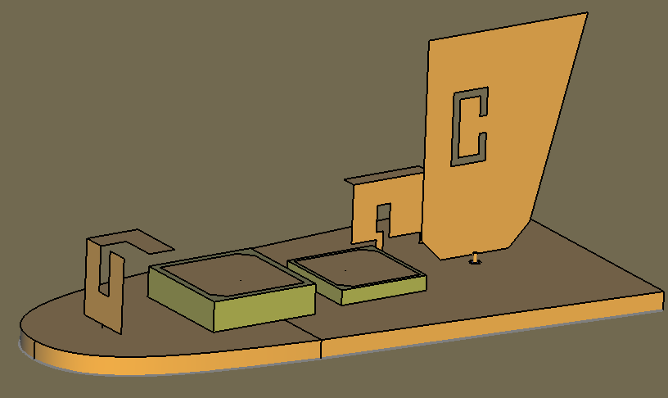
Simulation model of antennas inside a “shark fin” on the roof of a passenger car. Orange-brown is metal; the two green objects are plastic. The plastic cover (the actual shark-fin shape) has been removed.
Simulation results would include how much of the source power is actually radiated, and in which directions the radiation will go. A simulation result showing radiated electric fields may look like this:
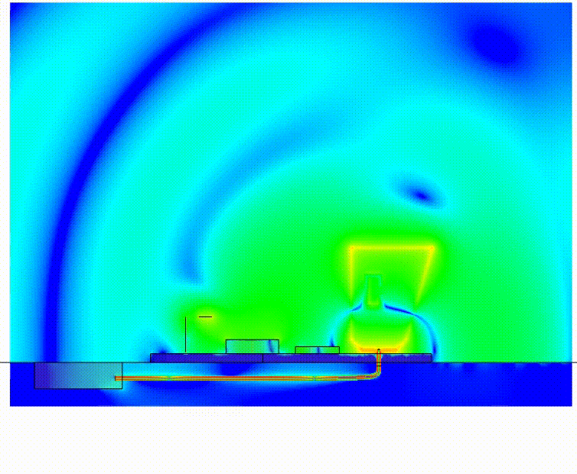
Simulation result: Electric fields traveling from equipment through a cable to the antenna, and being radiated by the antenna
This example illustrates the components that electromagnetic simulation tools can optimize:
- Cable cross section and materials for good power transfer. (Typical simulation models don’t include much cable; the cable in the image is long for illustration purposes).
- Connector geometries at the start and the end of the cable.
- Filter(s) in the receiver equipment.
- Antenna shape and materials.
- Antenna placement: location on the roof, proximity to windshield or to other antennas.
Further questions that the simulation tools can answer:
- Does unwanted radiation from the cable itself remain within certain limits?
- On non-civilian vehicles, if this is a high-power antenna, how does the radiation affect nearby people?
- If the car drives a given trajectory in a city or in a rural area, how well can it communicate with available cell-phone towers or other types of communication stations?
- In non-civilian scenarios, how much interference from other transmitters is received, and is there a better operating frequency?
The realm of full-wave electromagnetics is also the realm where electrical phenomena may become less intuitive.
As an example of intuitive behavior without electromagnetic effects, consider electrical power that is supplied to households. The electrical power neatly follows the power lines through the streets, around corners, and into the houses. In that application, frequencies are 50 or 60 Hz (wavelengths are thousands of kilometers, much larger than geometries of interest). We consider those frequencies (where wavelengths are more than ten times larger than geometries of interest) low frequencies, and expect no significant radiation.
As an example of non-intuitive behavior, to send files from one computer to another at high data rates through a wired connection, one needs a well-designed cable with well-designed connectors. Otherwise, the signal will not follow the wires in the cable well. A signal with a high data rate will involve high frequencies, e.g., hundreds of MHz. If the wires between the computers are not well designed, a fraction of the signal flies out of the wires and causes unwanted effects such as radiated interference on other devices and bit errors in the arriving file. If the connectors are not well designed, they won’t pass all the power, even if they offer a well-conducting metal path.
Let’s look at electromagnetic applications and develop some insights.
All examples in the book were produced with Siemens electromagnetic simulation software. Students can download a free full-featured version of the software at the
Feko Academic Hub.

This IS A preview
This document only serves as a preview to the full eBook. You can review the table of contents and read chapter 5 in its entirety.
If you would like to access the full eBook, please fill out the form on this page and download it for free.
5 Antennas

5.1 What causes electromagnetic radiation?
Suppose we have generated a signal inside an electronic device, and want to send it wirelessly to another device. The electronic circuits in the device may already radiate a small fraction of the signal by themselves, but that is usually too little to be practical. Actually, if electronic circuits radiate, it is usually called electromagnetic interference and blamed on poor design. To transfer power efficiently from the circuit to radiation, we need a special geometry that accepts the power from the circuit and radiates it easily into the air. That would be the antenna. The same antenna, once we have it, can just as easily be used to receive incoming electromagnetic radiation and transfer it to the circuit. This two-way ability is called reciprocity. It is a fundamental property of most antennas (exceptions may involve uncommon materials).

Let’s start with a fundamental physics question: what causes electromagnetic radiation? The answer is: accelerating charges. If we can make charged particles not simply move but accelerate, those particles will emit photons, i.e., radiate electromagnetically.
Oscillation involves acceleration. To generate electromagnetic radiation, the best way is to use an alternating voltage that makes electrons oscillate, i.e., that “yanks” the electrons back and forth rapidly on a suitable geometry. Enter the dipole antenna.

5.2 Dipole antennas; principles of directivity and gain
A dipole antenna consists of two metal arms with a source, e.g., a voltage source, between them. This voltage source in the simulation model could be a simplification of a connected transmission line from an electronic device. The voltage source, which changes polarity many times per second, pulls electrons up one moment and pushes them down the next moment, then pulls them up again, and so on. That involves a lot of acceleration. Power is transferred from the electrons to escaping electromagnetic radiation. The dipole antenna works well at a frequency where each arm has a length of a quarter of the wavelength. For instance, if the dipole arms are 1 m each, then the antenna works well at 75 MHz (wavelength 4 m).


A dipole antenna with a voltage source. Dipole arms are often ¼ of a wavelength each to obtain a resonance.
The current on a dipole antenna is strong near the center and is zero at the tips, because at the tips the electrons cannot move any farther.
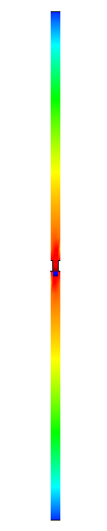
Current distribution in a dipole antenna. Red = strong, blue = weak.
The electric and magnetic fields close to the dipole are shown below. The electric fields are strongest away from the center, because during any half oscillation electrons have been forcefully removed from one arm and pushed into the other arm. The charges accumulate where a traffic jam occurs, closer to the tips than to the center. Of the two red areas on the electric field plot, one has the field lines pointing toward the antenna and one away from the antenna, due to the fact that the charges on the arms have opposite signs. These directions oscillate rapidly, as the charges are being forced to oscillate.
The magnetic field, which consists of circular field lines around the current, is strongest in the center, where the current magnitude peaks. The magnetic field (pointing along horizontal circles in this example) also changes direction rapidly as the current oscillates.
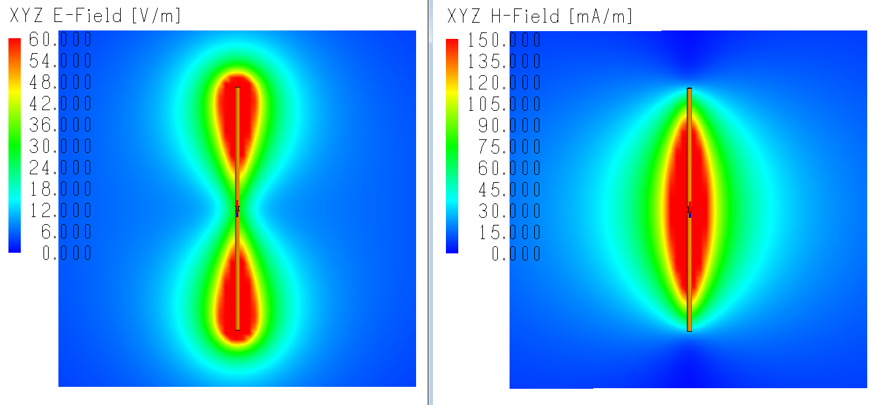
Electric and magnetic fields near the dipole antenna
The oscillating electric and magnetic fields form electromagnetic waves that carry power away from the antenna. The antenna radiates.
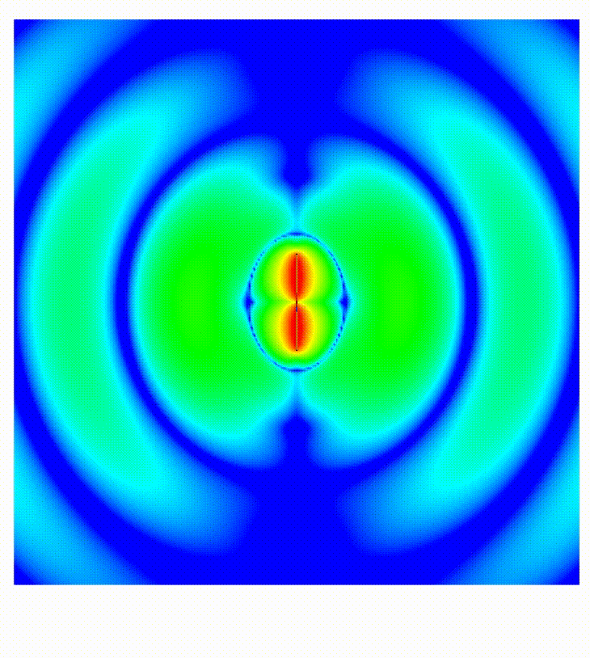
Electromagnetic waves radiating from the dipole antenna
Information on how the radiated power is distributed over all directions is usually presented in the form of a far-field radiation pattern. The images below show the pattern in 3D as well as a 2D pattern cut in one of the principal vertical planes.
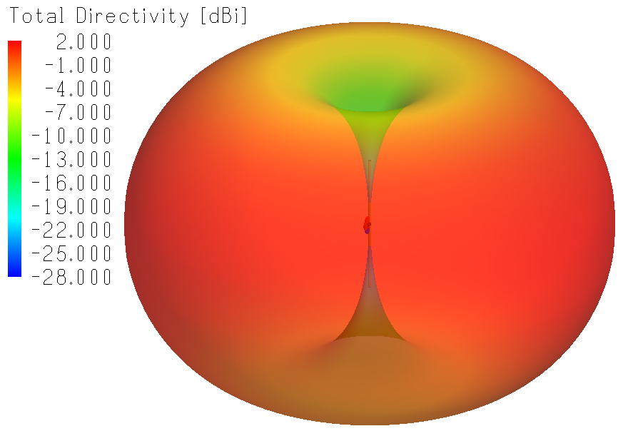
Dipole 3D radiation pattern. The radiation travels sideways in all directions; no power travels straight up or down.
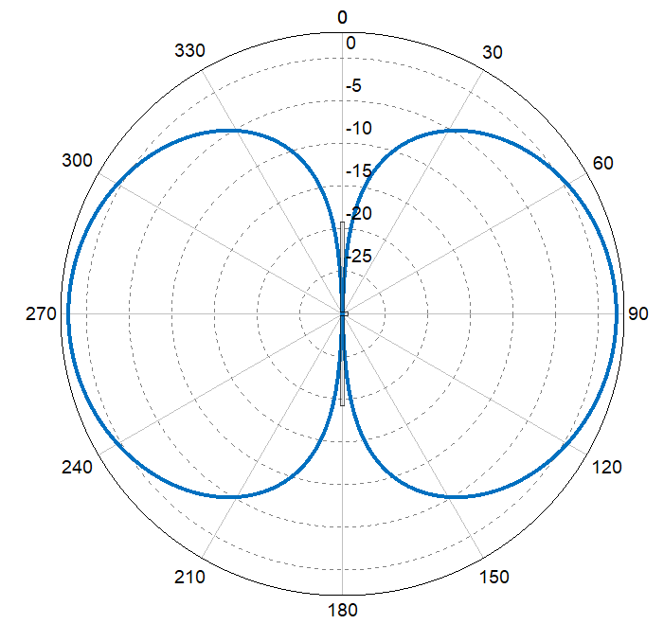
Dipole 2D radiation pattern, dB scale
The radiation patterns above display a direction-dependent quantity called directivity. Let’s see what this is. Suppose an antenna radiates uniformly in all directions, such that the 3D radiation pattern is a smooth sphere. In that case, the directivity is defined as being 1 (which is 0 dB) in all directions. Such an antenna, which does not exist, is called an isotropic antenna. For a real antenna, the directivity specifies the distribution of the radiated power relative to an isotropic antenna. In the case of the dipole, if the fraction of radiated power traveling sideways is 1.6× as much as the fraction in the case of the isotropic radiator, then we say that the dipole has a directivity in that direction of 1.6, or, in dB, a directivity of 2.1 dBi (dB relative to isotropic). This is regardless of whether we excite the dipole with 1 Volt or 100 Volt. It is only about the relative angular distribution of radiated power.
A related quantity is the antenna gain. The is the directivity corrected for power loss in materials that form part of the antenna. For a metal antenna, directivity and gain are practically the same. When the antenna has dielectric materials, such as an antenna on a dielectric substrate, then the gain can be noticeably lower than the directivity.
Even for ideal lossless antennas, it would be too good to be true if all the power from the circuit were transferred to radiation. In reality, part of the power bounces back into the circuit. Let’s see how this depends on the frequency.
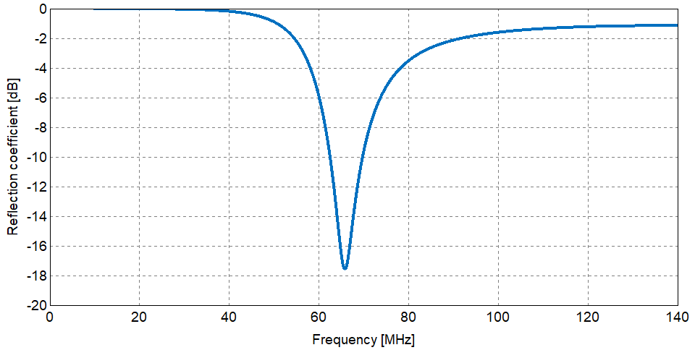
Dipole antenna reflection coefficient as a function of frequency. When the reflection coefficient is small (below -10 dB), the antenna radiates well.
This dipole antenna works well (S₁₁ < -10 dB) from 62 to 70 MHz. When frequencies are below 35 MHz (antenna smaller than 1/8 of a wavelength), the antenna radiates almost no power. Remember that we had said in earlier chapters that we don’t expect structures smaller than a tenth of a wavelength to radiate. This dipole antenna illustrates the point well.
The graph shows clearly that, if one uses an antenna slightly outside its intended operating band, the radiated power can fall significantly. This effect is sometimes included in information on the gain, and is then called the realized gain. The plot below shows the directivity and the realized gain in the horizontal direction as a function of frequency.
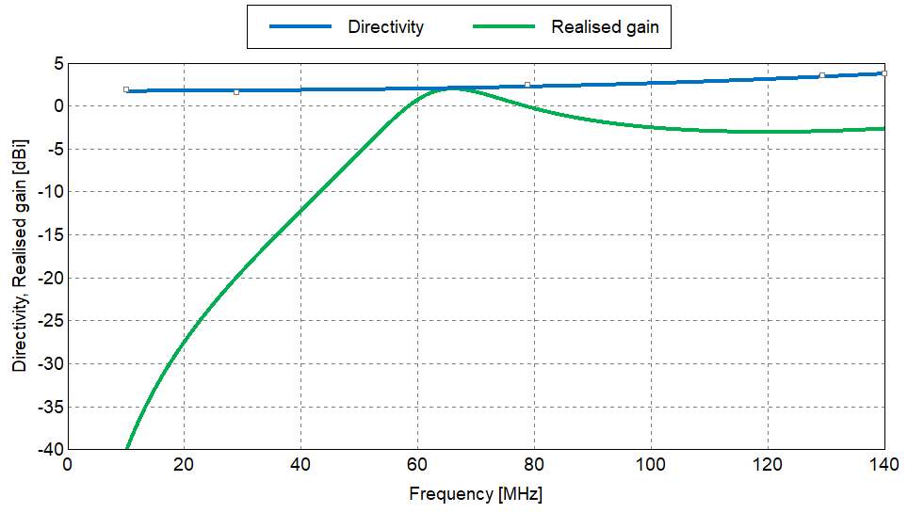
Dipole Antenna Directivity and Realized Gain in the horizontal direction as a function of frequency. Directivity is based only on the shape of the radiation pattern; realized gain takes losses and reflection into account. The two are almost the same at the frequency where the antenna radiates well.
The realized gain is a useful measure of how much we lose when we operate the antenna away from its resonance frequency.

5.3 Monopole antennas
A dipole antenna has a small disadvantage: it has to be mounted above the building or vehicle on which it is used. When we mount the antenna above a building or vehicle, we have to be careful that the supporting structure and the feeding cable won’t affect the antenna properties too much. Fortunately, there is an easier antenna that produces a comparable antenna pattern: the monopole antenna. It is just the top half of a dipole antenna, mounted on a metal plate. A voltage source is applied between the plate and the bottom of the antenna. The plate functions like a mirror, as if the bottom half of the dipole antenna were present as well.

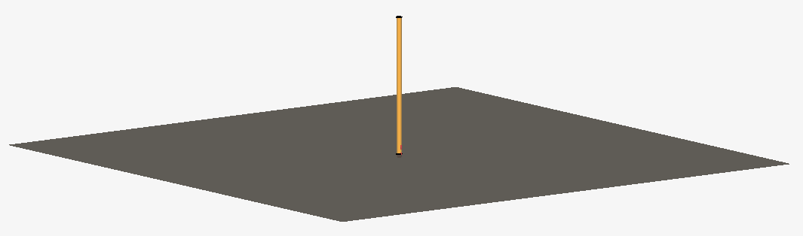
Monopole antenna on a flat metal plate. The monopole is often ¼ of a wavelength each to obtain a resonance
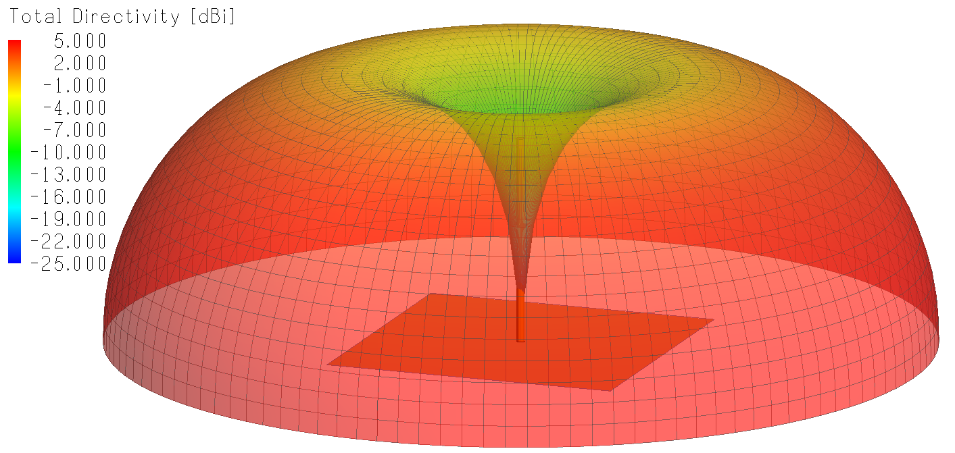
Monopole antenna pattern. The radiation travels sideways in all directions, no power radiates straight up. For a very large ground plane, the radiation below the ground plane is negligible.
The monopole antenna pattern looks like the top half of the dipole antenna pattern. The values for directivity and gain come out 3 dB higher, because, in the case of the monopole, the available power can only go into the top half space.
Examples of monopole antennas in practice include a radio antenna on a car, an AM broadcast radio mast, and an HF antenna (will be explained below). Variations on monopoles are used on many vehicles and structures.
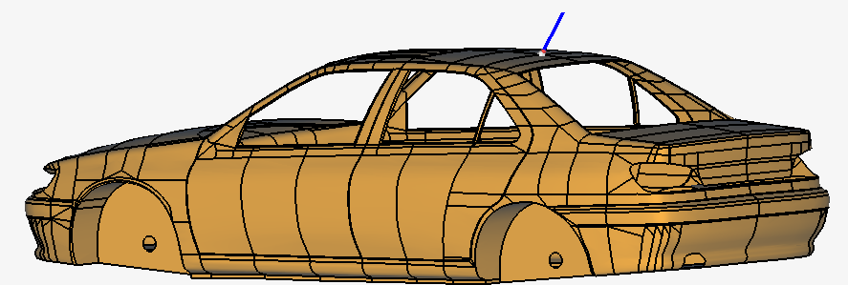
Monopole antenna on the roof of a car
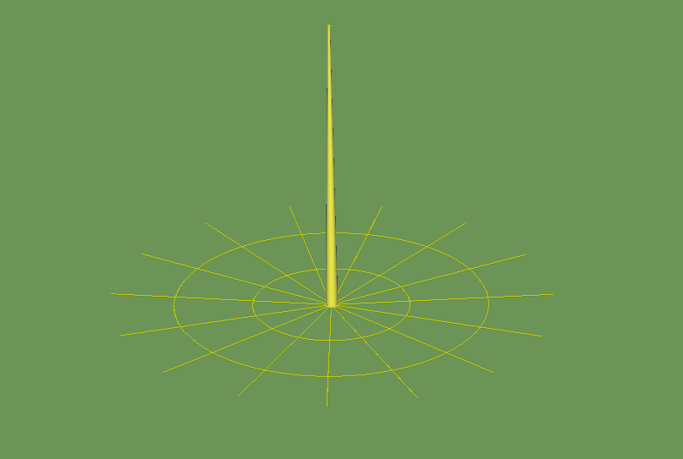
Tall AM radio mast in a field. The star-shaped structure is metal buried in the soil to provide good electrical grounding. Due to the large wavelength, the mast has to be tall.
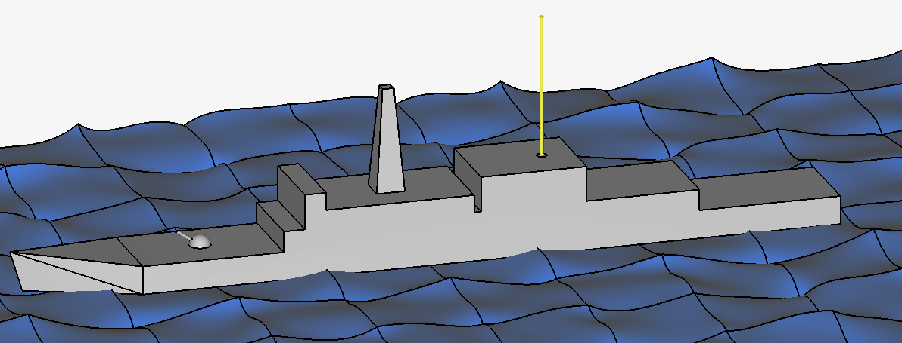
HF Antenna (bright yellow object) on a ship. Due to the large wavelength, the antenna has to be tall.
For the car antenna, the car roof forms the ground plane. Of course, the car shape, not being planar, distorts the pattern significantly, but the antenna works well enough in practice. For the AM radio mast, buried metal provides part of the ground plane, while the soil itself, which tends to have a modest electrical conductivity, adds more electrical grounding. “AM” stands for amplitude modulation; this is used for broadcasting stations with frequencies not far from 1 MHz (e.g., from 540 kHz up to 1700 kHz). At 1 MHz, a quarter wavelength is 75 m, so a mast with a height in that order would work well. Furthermore, a tall tower helps to achieve a long range over terrain. Extremely tall antennas are also used near the coast for communication with submerged submarines. In this case, frequencies may be much lower than 1 MHz, because low frequencies can penetrate farther into sea water than high frequencies (in sea water, the attenuation is 55 dB per wavelength).
“HF” stands for “High Frequency”, which is a designation for the band between 3 and 30 MHz. These frequencies are useful to transmit far beyond the horizon, because the ionosphere reflects the signals at these frequencies. Therefore, HF radio can cover large distances. At 3 MHz, the wavelength is 100 m, so a quarter-wavelength monopole would be 25 m tall. There are techniques to make the antennas smaller, but you can see why these antennas will tend to be tall.

5.4 Matching circuits
In many applications, there is a desire to make antennas smaller. This is especially the case in cellular phones and gadgets like smart watches. While older cellular phones had an exterior antenna, nowadays antennas are integrated in the device, where there is not much room. An antenna can be made to work well at a different frequency partly by giving it an intricate shape, partly by using materials that locally shrink the wavelength, and partly by attaching a matching circuit. We will present an example below.
For a monopole antenna with a length slightly larger than 1 m, the reflection coefficient magnitude looks like this:
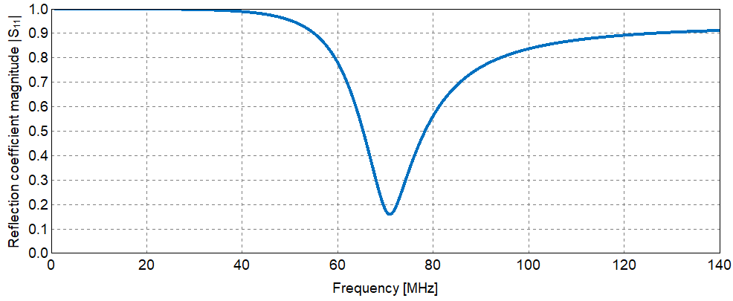
Typical monopole reflection coefficient magnitude. This plot gives an impression of the operating bandwidth.
The reflection coefficient also has a phase, simply because the signal that comes back toward the source will have both magnitude and phase. Earlier, we had seen that the reflection coefficient is related to an impedance that is “seen” by the signal as it emerges from the port.
Details: equation for reflections caused by an impedance Z on a transmission line with characteristic impedance Z₀:
$$Reflection= \frac{Z- Z_{0}}{Z+ Z_{0}} .$$
This can be manipulated to become
$$Z= Z_{0}× \frac{1+reflection}{1-reflection} .$$
Therefore, simulation software will not only report the reflection coefficient, but also the input impedance “seen” at the port. This input impedance will have magnitude and phase. If one works with complex numbers, the input impedance will have a real and an imaginary part. For this monopole antenna, it looks like this:
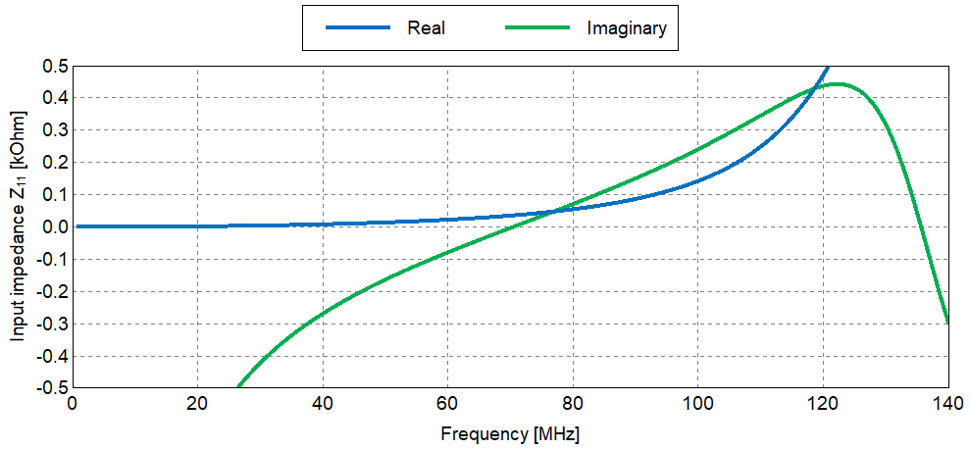
Real and imaginary parts of the monopole input impedanceZ₁₁ “seen” by the source. At resonance, the imaginary part crosses zero. Ideally, the real part of Z₁₁ is not far from the source impedance at that frequency, so the source impedance and the antenna impedance are “matched”.
The antenna will work best when the real part of Z₁₁ equals 50 Ohm (assuming the source and the feeding transmission line are at 50 Ohm) and the imaginary part is zero. The first condition is met at 77 MHz and the second at 70 MHz. A frequency that satisfies both conditions doesn’t exist, but at frequencies between these two, the antenna functions well enough (S₁₁ < 10 dB).
Suppose we want to use this antenna at 40 MHz. At 40 MHz, |S₁₁| = 0.99, which is too high. One way to make this work is by adding a matching circuit between the port and the actual antenna.
Typically, a matching circuit consists of a capacitor and an inductor, one in series with the port and one in parallel. Techniques exist to derive the proper component values by hand; on-line calculators and dedicated software also exist. What follows here is an over-simplification.
Simplified details: The imaginary value of Z₁₁ at 40 MHz equals -269 Ohm. We know that capacitors have negative imaginary impedance while inductors have positive imaginary impedance. Hence, adding an inductor in series would be a good way to compensate the present -269 (imaginary) Ohm. Z_{inductance} = 2πfL An inductor of 1.07 µH will have an impedance of +269 (imaginary) Ohm. Let’s add such an inductor in series.

Zoomed-in image; the antenna extends well above the image. An inductor has been added by defining a second port close to the feed port and placing the inductor there. The feed port at the bottom has a voltage source, as before.

This was a step in the right direction: the reflection coefficient at 40 MHz has gone from 0.99 to 0.7.
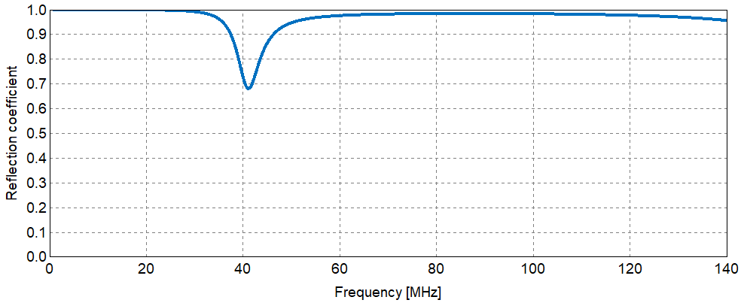
Improved reflection coefficient at 40 MHz after adding the inductor
The reflection coefficient at 40 MHz is not small, because the real part of the input impedance is still far from where it should be (50 Ohm in many cases).
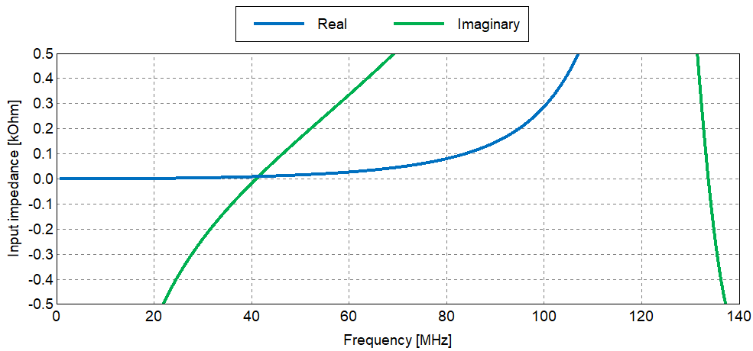
Real and imaginary parts of the input impedance of the antenna with inductor.The imaginary part crosses zero at 40 MHz.
Nevertheless, this illustrates how one can improve an antenna by adding circuit components. Maybe you have seen monopole antennas with a coil at the bottom. The coil may be there to function as an inductor.
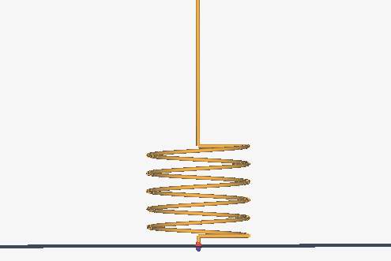
Monopole antenna with a coil at the bottom
With two components, a 1.18 µH series inductor and a 171 pF parallel capacitor, obtained from an on-line calculator, a small reflection coefficient is achieved at 40 MHz:
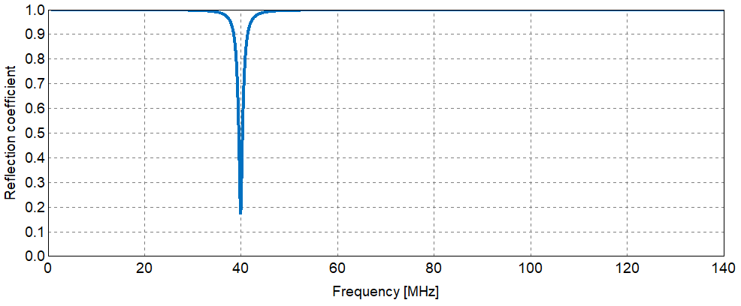
Reflection coefficient of a monopole antenna with a proper matching circuit. The reflection coefficient is small at the desired frequency.
Note that the antenna now works, but in a frequency band that is narrower than before. This agrees with a general rule: the smaller an antenna is (relative to the wavelength of interest), the narrower the operating band will be. This is often a serious limitation, because we want to be able to use a wider band to have flexibility to choose a frequency or to be able to send data (e.g., a video) with a high data rate. On the other hand, for an integrated GPS antenna in a smart watch, this is not a bad thing. The GPS signal is at a well-defined frequency and has a low data rate, so a narrow-band antenna can do the job. Furthermore, a narrow operating band will exclude interfering signals at other frequencies, which helps a lot to be able to detect the weak GPS signal.
For antennas much smaller than a tenth of a wavelength, even with a matching circuit it can in practice be difficult make them radiate well. This is due to losses in the materials, which can’t be avoided, and the sensitivity to the precise parameters of the matching-circuit components. An example can be found in [1].
[1] Miguel Fernandez-Munoz et al., “Miniaturized Flat Archimedean Spiral Antenna”, Applied Computational Electromagnetics Society Journal, Vol. 40, No. 01, January 2025, pp. 26-34. The radiation pattern of their small antenna, at a frequency where a matching circuit produces a small reflection coefficient, has a peak gain below -40 dBi. The peak directivity must be larger than 0 dBi, so most of the power that leaves the port is absorbed by losses in the antenna materials.

Occasionally, an antenna engineer might mention a Smith Chart. All you need to know is that it has something to do with antenna matching. It is a different (and non-intuitive) way to plot the reflection coefficient.
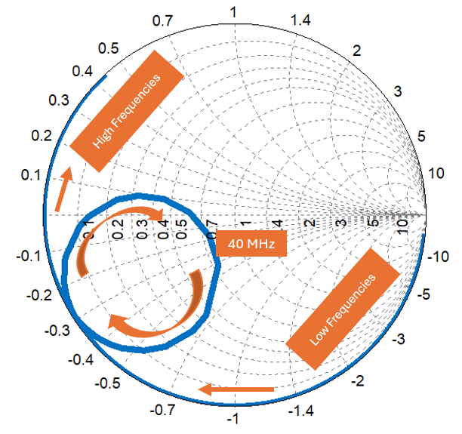
Smith Chart for the matched antenna. Arrows indicate the direction of increasing frequency.
A few properties of the Smith Chart:
- At frequencies where the graph is near the outer circle, the reflection coefficient is close to 1 and the antenna isn’t working;
- The graph always goes clockwise from low to high frequencies. So, if there are no markers, you can still see where the low and where the high frequencies are.
- At frequencies for which the graph comes near the center of the chart, where a number 1 is displayed, the reflection coefficient is small, meaning, the antenna is probably working.
- Antenna engineers have techniques to derive the required matching components from the Smith Chart. By now, most people probably use on-line calculators for this purpose.

5.5 Broadband antennas
In other applications, an antenna has to be able to operate over a very wide frequency band, e.g., from 2 to 18 GHz. This may be the case when we want to maintain flexibility in the type of application, or if we want to listen over a wide range of frequencies if anything is there (e.g., a hostile radar). Such antennas can also be useful to transmit and receive pulses of very short duration (e.g., on the order of a nanosecond), because for mathematical reasons a short pulse always contains a broad range of frequencies.
How would we design a broadband antenna? Picture it from the point of view of a signal that travels down a transmission line and meets the antenna. Depending on the antenna geometry, for some frequencies the signal flies out easily. We should find a geometry for which a certain wavelength flies out easily, and combine smaller and larger versions of that geometry in a smart way, so signals will always meet a geometry where its wavelength flies out easily. We could call that a frequency-independent antenna. Another approach is to make a smooth, gradual transition between the transmission line and free space, so the signal won’t encounter sudden discontinuities. Below, we will show and discuss several examples.
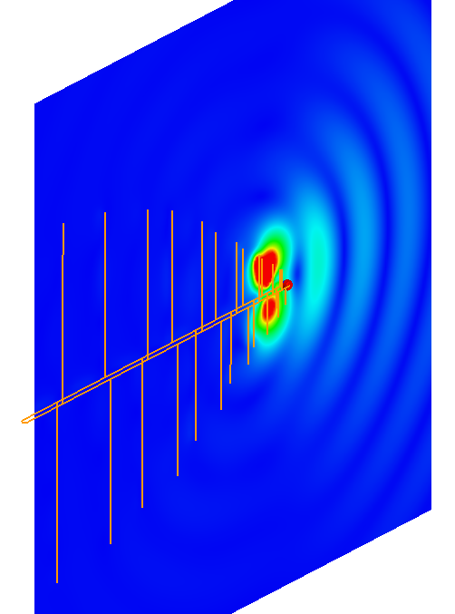
Log-Periodic Dipole Antenna. The signal travels along the horizontal part until it encounters vertical dipole arms with the right length for its wavelength. There, the signal is radiated.
The log-periodic dipole antenna has a series of dipole antennas mounted along a boom. The boom consists of two parallel conductors, so it can function as a transmission line. The signal source is connected at the end where the short antennas are, which is the right end in the above picture. A signal with a given frequency travels along the boom until it meets a dipole antenna with the right size to resonate at that frequency. The signal power enters that particular dipole antenna and is radiated. Due to the influence of nearby dipoles, the radiated signal travels predominantly away from the larger dipoles. A signal with a relatively high frequency is radiated by a short dipole close to the source, as shown in the image. A signal with a relatively low frequency ignores the short dipoles and will be radiated by a longer dipole farther from the source.
A log-periodic dipole antenna can function reasonably well over a bandwidth that spans a factor ten in frequency. The image below shows this for the reflection coefficient.
How to define “reasonably well”? Usually, an antenna is said to work well when the reflection coefficient is below 0.3 (for a reflection coefficient or an S-parameter, this value corresponds to -10 dB. This antenna does not quite achieve that low level over a range that spans a factor ten).
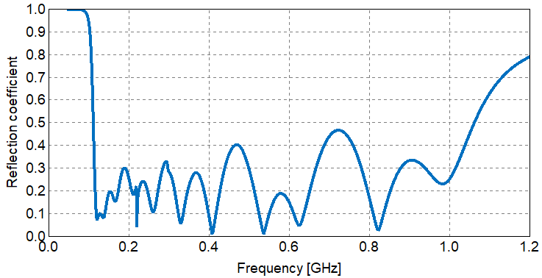
Reflection coefficient of the log-periodic dipole antenna. The reflection coefficient is low over a wide frequency band.
In the era before cable television, such antennas were often found on the roofs of houses.
Another frequency-independent antenna is the equiangular spiral antenna. The arms of the spiral look almost the same to signals with high and low frequencies. In the example below, there are two spiral arms. The connection to the source and/or receiver is in the center. High frequencies will tend to radiate close to the source, while lower frequencies will tend to radiate farther from the source.
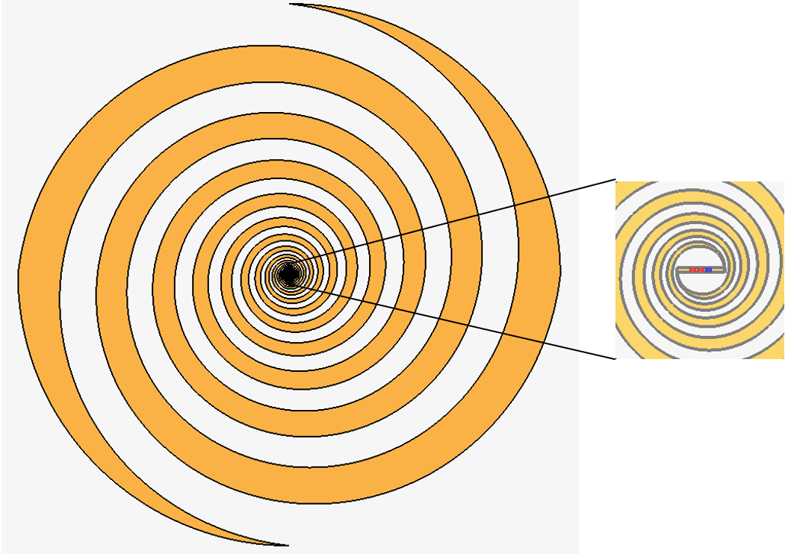
Equiangular spiral antenna with two arms. The port is in the center.
Such spiral antennas may be used on military airplanes and other vehicles to listen for hostile radar and then take electronic countermeasures (e.g., send out signals on the same frequency with the purpose of confusing or deceiving the radar). Since different radar systems can operate on a wide range of frequencies, the bandwidth of the spiral antenna has to be large.
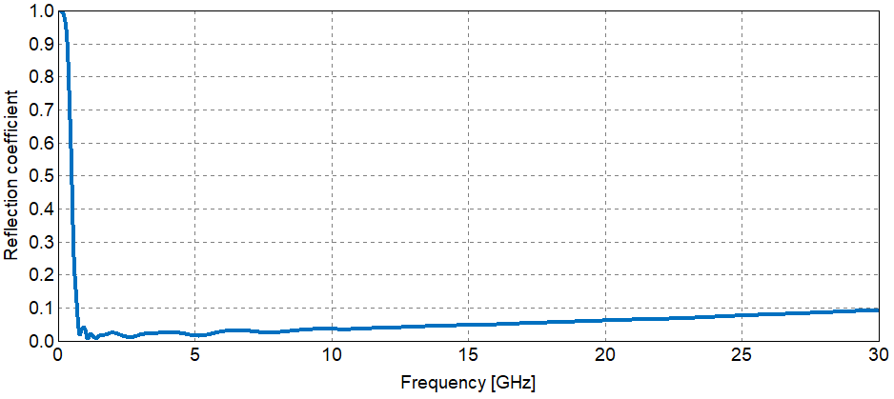
Reflection coefficient of a spiral antenna. The frequency bandwidth spans much more than a factor ten from lowest to highest frequency.
This spiral antenna is 20.5 cm across. From the reflection coefficient, we see that it functions as an antenna above 0.55 GHz, where the wavelength is 54 cm. The lengths of the arms towards the outside make the antenna work at such low frequencies. The bandwidth is astonishing; the highest operating frequency is far above 30 GHz in this example. The plot suggests that the operating frequency band might go up to 100 GHz. In practice, the fabrication of the details near the center with sufficient precision would be difficult. Still, a spiral antenna can easily achieve well over a factor ten in bandwidth.
A related antenna, used for the same purposes, is the sinuous antenna. The image below shows an example. Depending on how the arms are fed, it can be used for linear or for circular polarization. The spiral antenna is limited to circular polarization.
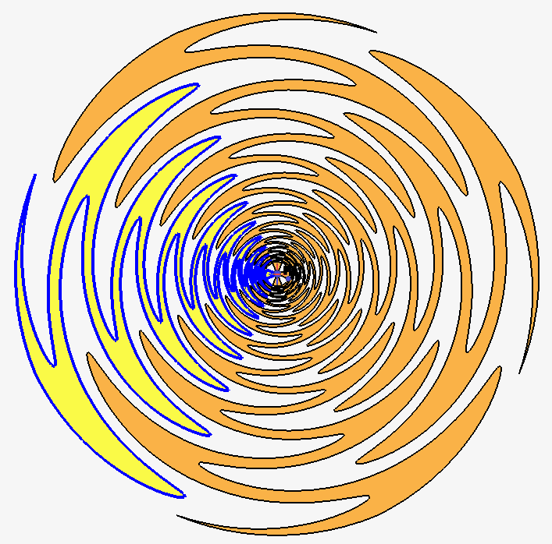
Four-arm sinuous antenna. One arm is highlighted to make the shape easier to distinguish. It offers more polarization options than the spiral antenna.

The figure below shows a Vivaldi antenna, made of thin metal. A voltage difference is applied in the narrow part of the separation between curved metal edges.
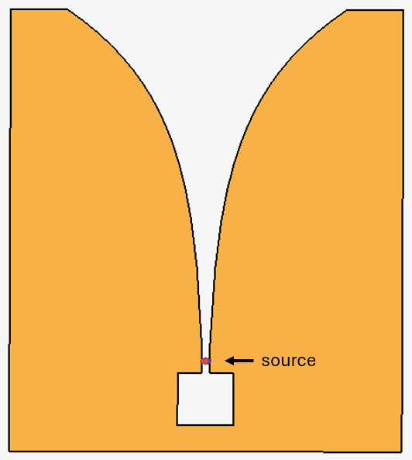
Vivaldi antenna. It achieves a large bandwidth due to the gradual transition from source to free space.
Above a certain frequency, the source excites a signal of which the currents travel along the edges to the wider part and of which the electric fields cross from one edge to the other. As the signal travels to the wider part, it radiates. This structure forms a smooth transition between a kind of transmission line (the narrow part) and free space.
This antenna works reasonably well over a range of frequencies that spans a almost factor ten, as indicated by the plot of the reflection coefficient below.
As mentioned before about “reasonably well”: Usually, an antenna is said to work well when the reflection coefficient is below 0.3 (for a reflection coefficient or an S-parameter, this value corresponds to -10 dB. This antenna does not quite achieve that low level over a range that spans a factor ten).
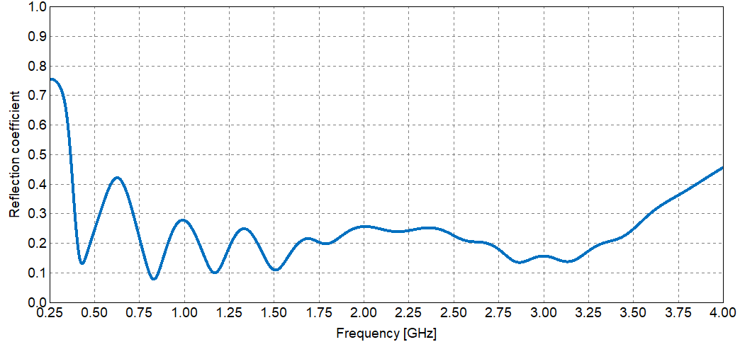
The Vivaldi antenna reflection coefficient is low over a wide frequency band.
The antenna pattern forms a broad lobe, as shown below:
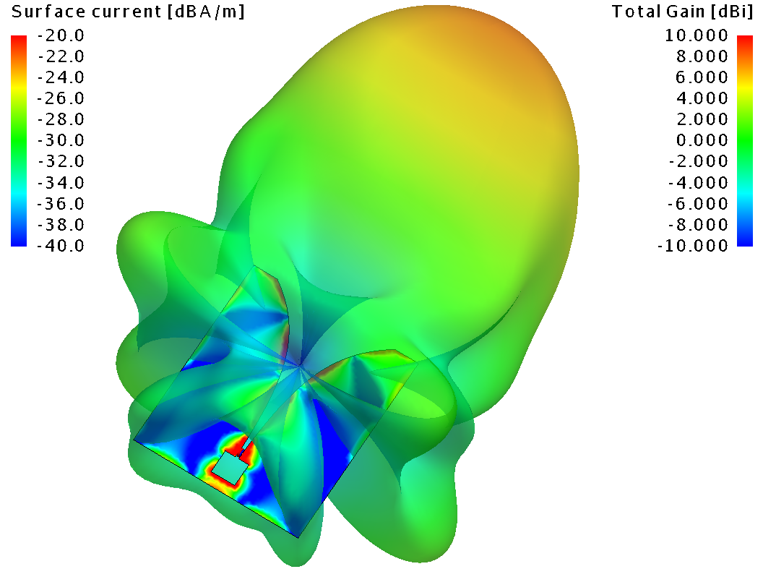
Vivaldi antenna: currents along metal edges, and radiated fields, at 1.2 GHz
An array of receiving Vivaldi antennas has been used in astronomy to gather data in in a band of frequencies.
A TEM horn is a horn antenna without side walls. (TEM stands for Transverse ElectroMagnetic, but that is not important right now). The plates of the TEM horn antenna form a gradual transition from the transmission line (e.g., horizontal parallel strips) to free space.
A conventional horn antenna with side walls is more limited in bandwidth. In particular, a horn with side walls will have a low-frequency cutoff, when a half wavelength doesn’t fit sideways between the sidewalls anymore. This is directly related to the low-frequency cutoff of a rectangular waveguide. A horn with side walls is better than a TEM horn at confining the wave and forming a narrow beam. Techniques exist to extend the bandwidth of a horn with sidewalls by placing a Vivaldi-type ridge in the middle, halfway between the two side walls.
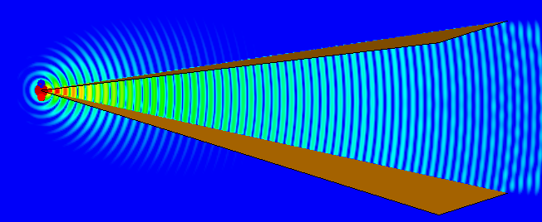
TEM horn antenna with outgoing electromagnetic waves.

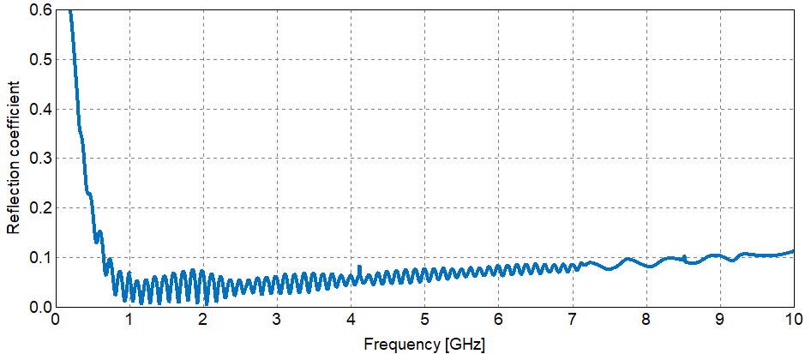
Reflection coefficient of the TEM horn antenna. The frequency bandwidth spans much more than a factor ten from lowest to highest frequency.
The length of the horn in this example is 1.08 m. From the reflection coefficient, we infer that the TEM horn functions as a good antenna when the length of the horn exceeds the wavelength of the signal (at 300 MHz, the wavelength is 1 m). The bandwidth is much larger than a factor ten.
A TEM horn is used in situations where the ultra-wide bandwidth is needed to form a very short and strong pulse in time. Applications include ground-penetrating radar to find buried objects, through-the-wall radar, and electromagnetic weapons to disrupt an opponent’s electronics. Although a spiral antenna can also offer sufficient bandwidth, it doesn’t have the high power-handling capability due to the small details near the center. The image below shows an example of ground-penetrating radar, in this case with 32-cm antennas.
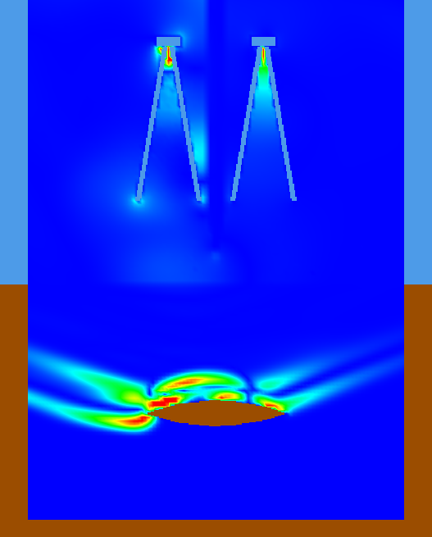
Ground-penetrating radar for detection of buried objects. The large frequency bandwidth is used to emit a pulse of very short duration. In this snapshot in time, the pulse from a transmitting antenna has just reached a buried object. A reflection is forming, to be detected by the other antenna.
The radar has two antennas, one to transmit a short-duration pulse and one to detect reflections. In the image, which is a snapshot in time, the pulse has just reached the buried object and part of the power is being reflected.
Details of the simulation project:
The top half of the model in the image is air (light blue); the bottom half is soil (brown). The deep blue color in both regions is part of the field plot (fields are practically zero in the deep blue in this snapshot in time). The soil has a relative dielectric permittivity ε_{r} = 8 and a conductivity 0.01 S/m. These are common parameters for soil. The wavelength in the soil will, in this case, be √8 times shorter than in air. Of course, there is a wide variety of soil types, and conductivity depends strongly on moisture content.
When a short-duration pulse excites the transmitting antenna, part of the power causes “ringing” of the antenna: some resonances exist that decay slowly. It’s a bit like giving a bell a short-duration knock: a tone, plus possibly overtones, can be heard for a time duration that takes longer than the knock itself. Remember that a short-duration pulse contains mathematically a very broad spectrum of frequencies. The “ringing” is one reason for using separate antennas for transmitting receiving: the reflection from the buried object might arrive before the “ringing” has decayed sufficiently, and you want to detect it with a quiet antenna. Even using separate antennas may not be sufficient: fields from the transmitting antenna easily reach the receiving antenna by traveling sideways. Therefore, a screening object has been placed between the two antennas. Also, a resistor has been added in series with the voltage source of the transmitting antenna to dampen the resonances. The addition of a resistor turned out to be very effective.
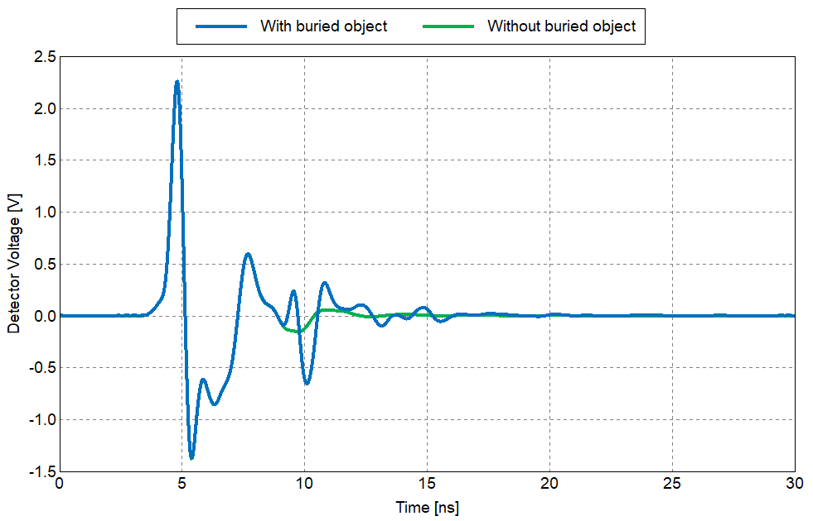
Detector voltage with and without a buried object present. Up to almost 9 ns, the green and blue lines coincide. The buried object is detected around 10 ns (blue line).
In the result comparison above, the reflection from the air-soil interface reaches the detector between 4 and 5 ns. Up to 9 ns, the blue and green lines, with and without buried object, are identical. The reflection from the buried object reaches the detector between 9 and 10 ns. Fortunately, it is larger than any residual “ringing” (note that the green line is not zero at 10 ns).
Note how small the reflection from the buried object is. The signal has weakened due to the two-way distance, and the conductivity of the soil has attenuated the signal further.
Simulations like this can be used to improve the antenna design, investigate the effectiveness of different pulse shapes depending on soil type and object type, and provide input data to signal-processing algorithms under development.

5.6 Patch antennas
Thus far, we have described antennas that form a sizable addition to an existing geometry. For aesthetic reasons, or for reasons of aerodynamics, or to save space, it is attractive to have antennas that lie flat on a surface and add little thickness or volume. However, most antennas, e.g., dipole antennas and spiral antennas, won’t work anymore if they are too close (a tenth of a wavelength or less) to a metal surface. Electrons in the metal surface sense the fields from the antenna, and they immediately move until they feel no field anymore. This means that the field from the antenna, which was a wanted field for radiation, is mostly gone.
Patch antennas, on the other hand, can be extremely close to a metal plane. The figure below shows a couple of rectangular patch antennas. From bottom to top, the stack-up is (1) a metal ground plane; (2) a dielectric substrate, thickness typically 1 mm or less; (3) a metal patch with thickness on the order of 0.02 or 0.03 mm. Patch antennas can easily be part of a microstrip circuit that uses the same ground plane and substrate. They can also be fed from below with a coaxial cable, or from a microstrip line below the ground that couples to the patch through a slot in the ground plane.
In simulations, the thin metal is typically modeled by a 2D object. The simulation tool may ask you to specify a thickness, but the object in the model remains a 2D object. A 2D object gives a better mesh quality and a more efficient simulation than a very thin 3D object.
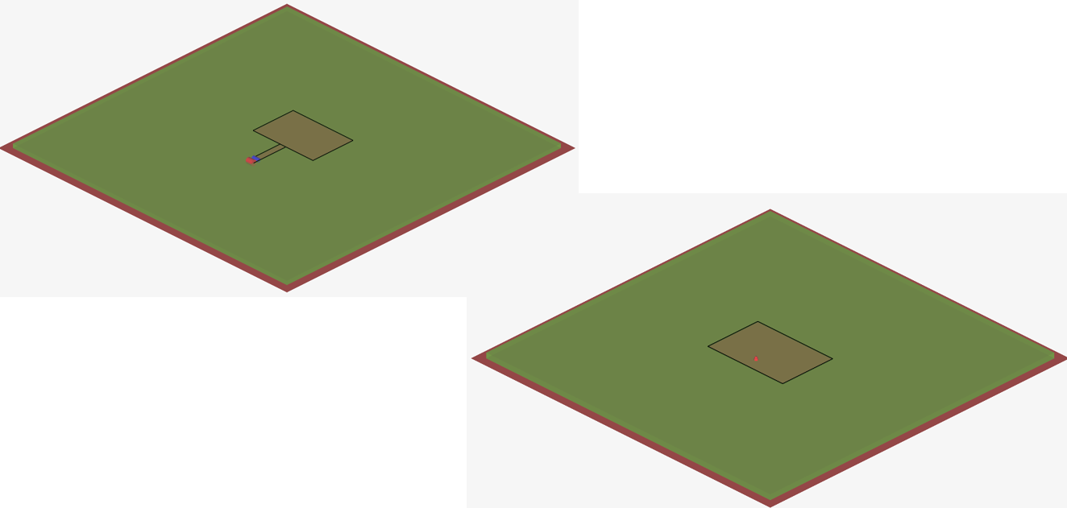
Rectangular patch antennas. Left: fed by a microstrip trace. Right: fed by a co-axial line from below (at the location of the red dot).
How can the patch antenna, which is close to the ground plane, radiate? When the patch is half a wavelength wide, a resonance can exist. The images below depict this.
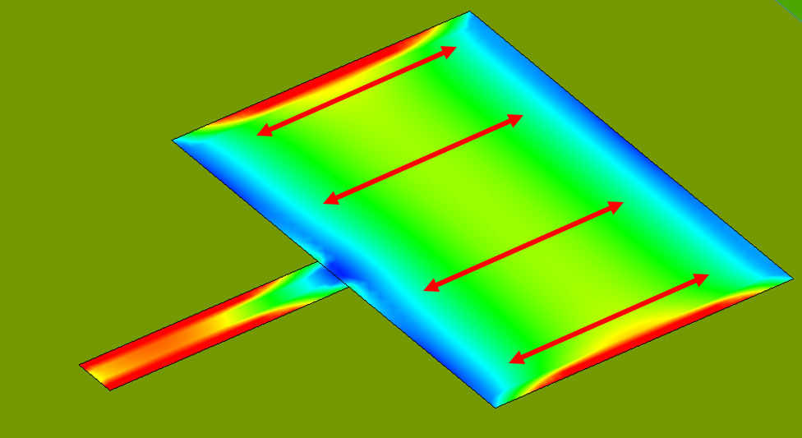
At resonance, currents on the patch oscillate as indicated by the arrows.
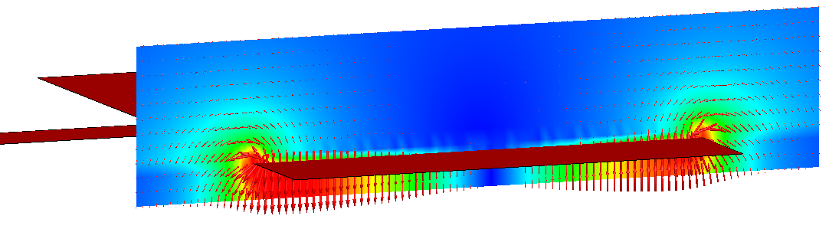
At resonance, electromagnetic fields radiate from the volume below the patch, at two of the four edges of the rectangle. The electric fields are strong where the current is weak.
The currents on the patch surface oscillate back and forth, as indicated by the arrows. The electric fields between patch and ground oscillate up and down, depending on which edge has temporarily a shortage or a surplus of charge. When the electric-field arrows point down at one edge, they point up at the opposite edge. Most importantly, waves radiate from the open side faces of the volume under the patch.
Because of this half-wavelength condition, the patch antenna is inherently a narrow-band antenna. In this example, which has a thicker-than-usual dielectric substrate, the bandwidth is 3% (the band where S₁₁ < -10 dB). For a patch antenna, 3% is a large bandwidth.
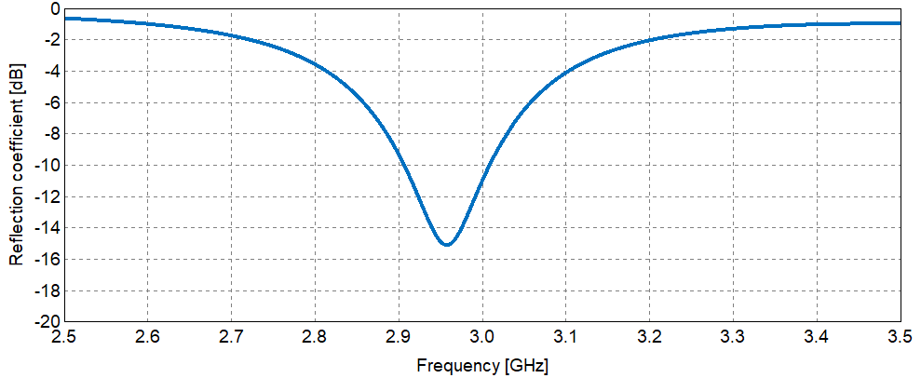
Patch antenna reflection coefficient. Bandwidth ≈ 3% in this example.
The radiation pattern is very broad, as shown below.
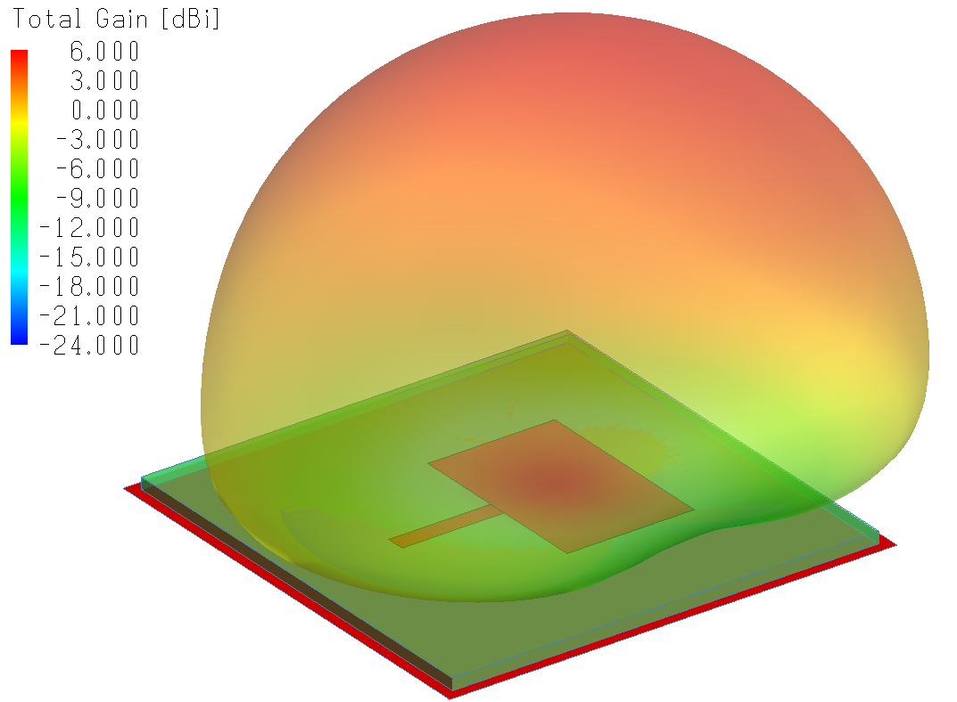
Patch antenna radiation pattern. The radiation goes mostly upward, but the pattern is very broad.
In simulations, the edges of the patch antenna have to be meshed finely to capture the current gradients and the field gradients well.
The patch antennas we have seen thus far are fed either by a microstrip trace that connects to the side or a coaxial cable that connects from below. In the latter case, the precise location of the connection point is important. A third way to feed the patch is from below the ground plane through an aperture (a slot) in the ground plane. This can be easier to fabricate than the coax connection, and may be more durable.
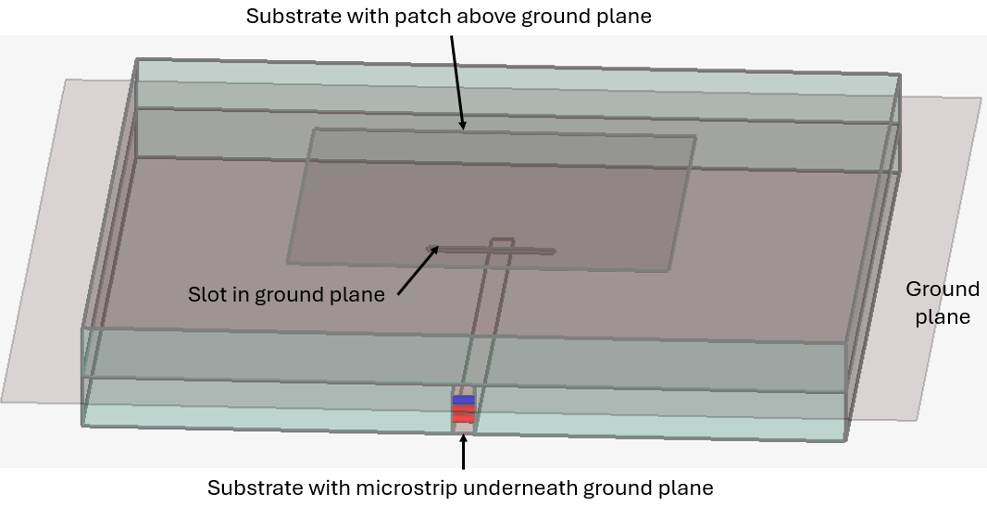
Aperture-coupled patch antenna (substrate thickness exaggerated to make the multilayer stack up clear! The slot is actually under the center of the patch, and the microstrip extends about a quarter wavelength beyond the slot.)
The fields in a vertical cross section in the direction of the microstrip look like this:
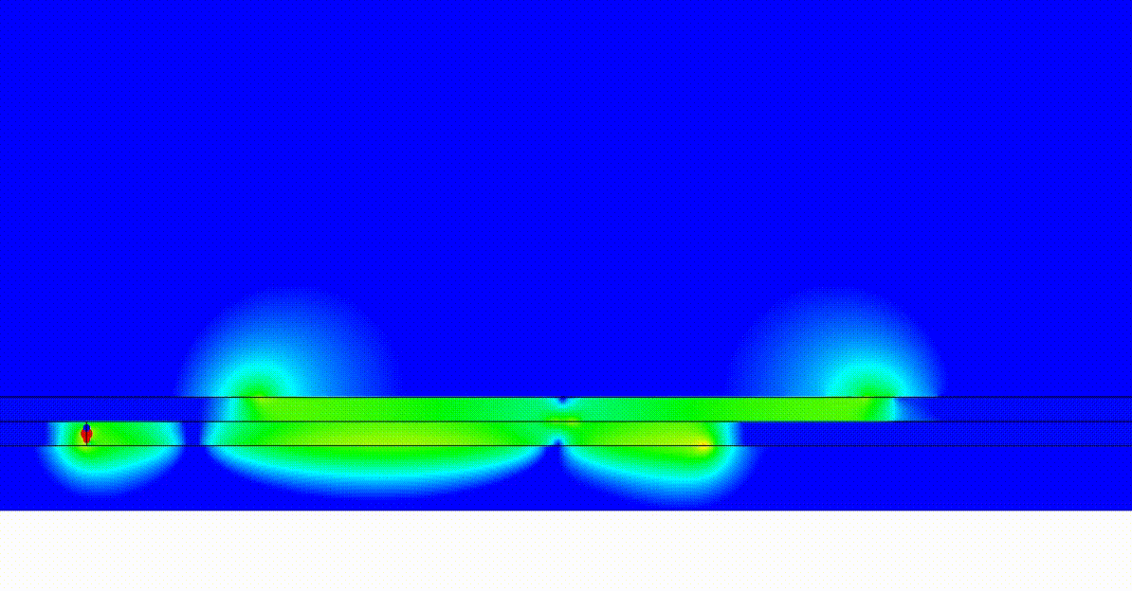
Field animation of the aperture-coupled patch antenna. The microstrip signal travels from the left to the right below the ground plane. The patch is above the ground plane. At resonance, the power travels from the microstrip to the antenna through an aperture located under center of the patch.
The microstrip trace extends about a quarter wavelength past the slot and then simply ends. The currents have to be zero at the end, and will be relatively strong around a quarter wavelength from the end. Since the slot is in the way of the return current in a location where the return current is strong, an electric field will exist across the slot. This excites the resonance under the patch, which in turn radiates from the edges. The phases of the radiated fields from the two edges add up constructively in the upward direction.

5.7 Horn antennas
The horn antenna is a conceptually simple antenna that is popular in many applications, e.g., in measurement setups and in point-to-point communication links. It is an antenna that supports high power and has a large frequency bandwidth. The directivity is high. In other words, you have a good connection if you point it correctly.
In the image below, the horn is fed by a rectangular waveguide. Remember that the electric fields in a rectangular waveguide point between the broad walls (here, bottom and top faces), and stay away from the short walls (here, the vertical side faces). This behavior continues as the horn gradually widens. The horn forms a smooth transition between the waveguide and free space. An open-ended waveguide without a horn antenna would have a significant reflection coefficient, but with the smooth transition added (i.e., with the horn added), the reflection coefficient is low.
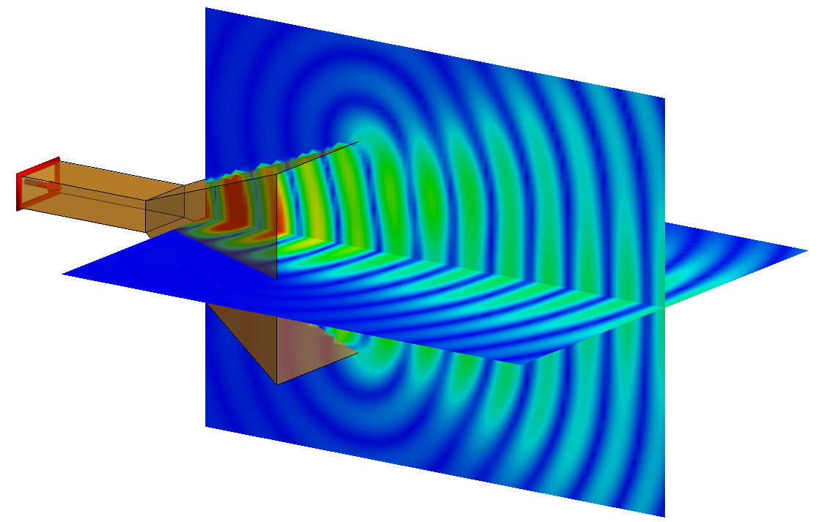
Electric fields radiating from the horn antenna
Note that the electric fields, when they exit the horn, have a modest tendency to crawl around the top and bottom edges. That leads to side lobes in the far-field pattern, as is visible in the image below. The fields don’t try to crawl around the side faces of the horn aperture, because they still stay away from those faces, like they did inside the waveguide.
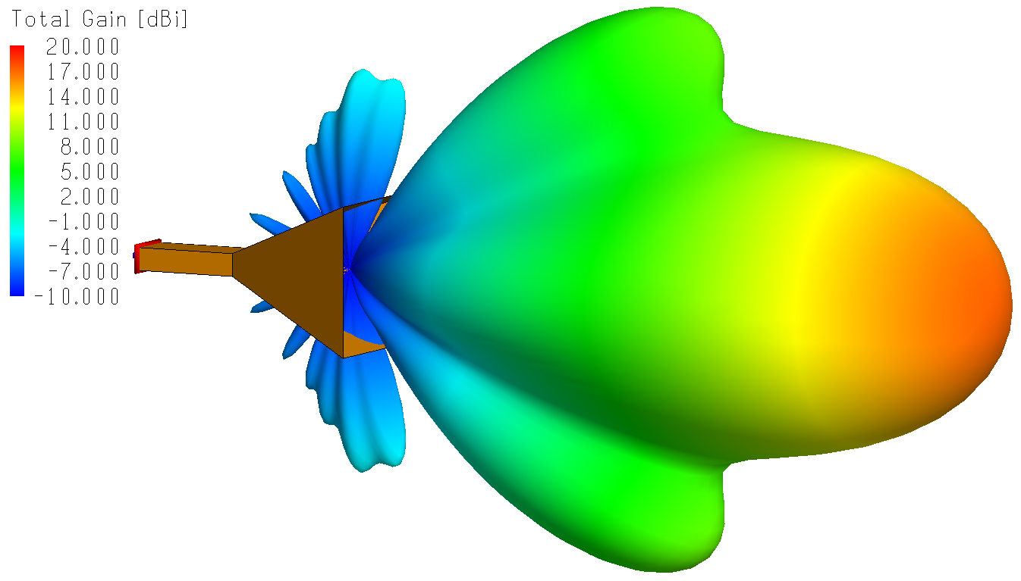
Far-field radiation pattern of the horn antenna
As for directivity: the larger the aperture of the horn is, in terms of wavelengths, the higher the directivity will be, i.e., the narrower the beam will be.
You may hear antenna engineers mention a corrugated horn. That is a horn of which the walls have a complicated structure that aims to avoid sidelobes by keeping the fields mostly away from all the walls. When the fields stay away from the walls, at least in the wide part of the horn, the tendency of the fields to crawl around edges at the aperture will be less.
The horn aperture has to be several wavelengths in size. To keep the size of the antenna practical, horn antennas are almost always used for multi-GHz frequencies. E.g., at 10 GHz, where the wavelength is 3 cm, a horn may have a size of 20 to 30 cm. This is a convenient size to work with, e.g., in an anechoic chamber.

5.8 Reflector antennas
To achieve a high directivity, i.e., a narrow beam, with a horn antenna, the antenna aperture has to be quite large. This is a general truth: small antennas have broad beams; to achieve a narrow beam, we need to create a broad, almost flat, coherent wavefront first. Other than with a horn antenna, a high directivity can also be achieved with a reflector antenna. The aperture is still large, but the antenna doesn’t need to be long and heavy. Examples of reflector antennas are TV dishes on houses, rotating radar antennas on military installations, and high-directivity antennas on satellites.
The dish typically has a parabolic shape, and the feed, which is small, has to be placed in the focal point or in the focal plane of the dish. The figure shows the principle. The optical equivalent is a parabolic mirror, e.g., in a lighthouse or in an old-fashioned handheld flashlight.
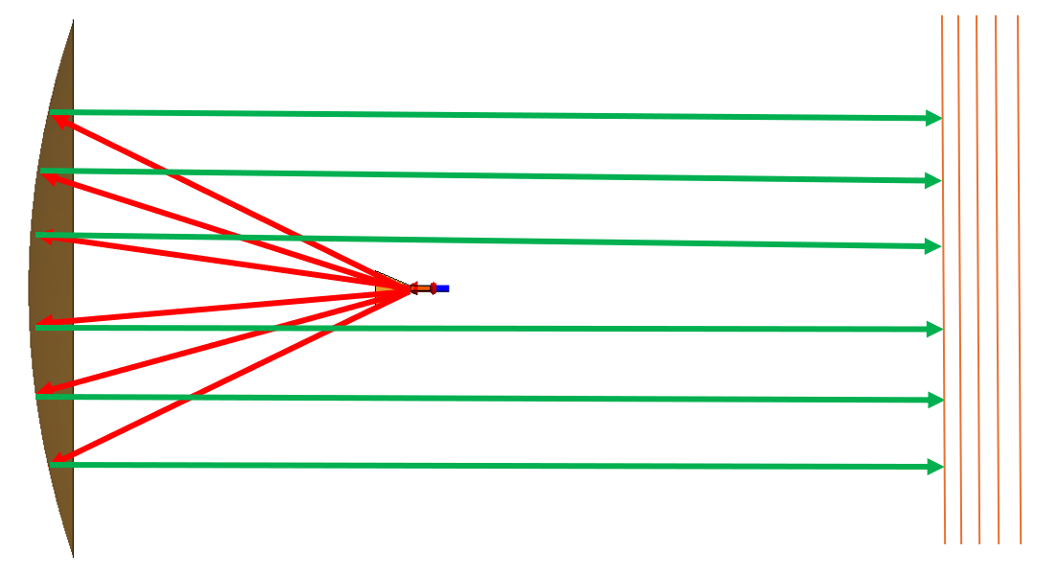
Principle of a reflector antenna. Red arrows: propagation from the source to the parabolic reflector. Green arrows: reflected power, forming a parallel beam. Orange: impression of the outgoing wave front.
Rays that emanate from the focal point are reflected by the parabolic dish in such a way that they form a flat, wide, coherent outgoing wavefront. The wider we can make such a wavefront, the narrower the beam will be. The wavefront will always expand, though. (This is also true in optical applications: even a laser beam expands if you monitor it over a large distance).
The image below shows the radiation pattern of a reflector antenna fed by a small horn. The feed horn is in the focal point of the parabolic dish. This affects the shape of the beam.
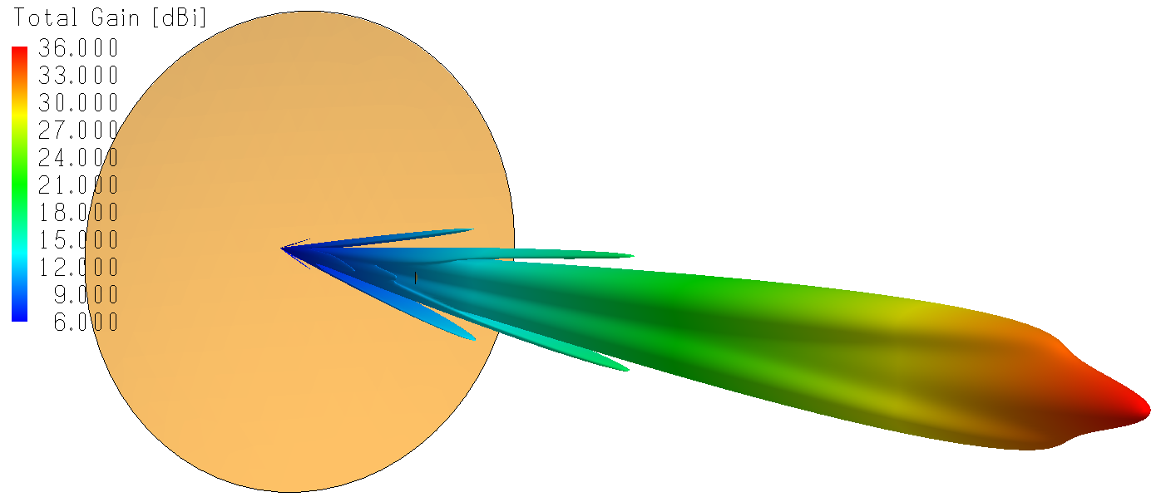
Radiation pattern of a parabolic dish fed by a small horn. The feed horn is in the beam and affects its shape.
In this example, the dish diameter is 1.08 m and the operating frequency is 10 GHz. Hence, the dish is 36 wavelengths across. In communications with geo-stationary satellites, which are at 36,000 km from the Earth, sometimes even larger dishes are used, and the peak gain may be over 45 dBi. The beam width may be 0.5 degree ≈ 0.01 radian. In that case, from 36,000 km, the satellite signal would have a “footprint” with a diameter of 360 km (more at latitudes away from the equator).

5.9 Phased-array antennas
We had mentioned the rotating radar antenna on military installations. It has a downside: it can only observe in the direction in which it is pointing. In all other directions, it is temporarily blind. Since the radar makes a full revolution every few seconds, this is not a major problem, but in a warfare scenario with many simultaneous and fast-moving threats, the ability to redirect the beam almost instantly into any direction is valuable. The phased-array radar offers this ability.
We know from the horn antenna and the reflector antenna that a narrow beam can be achieved by creating a broad, almost flat, coherent wavefront. One way to do this is by placing many small antennas in an array. The image shows an array of patch antennas.
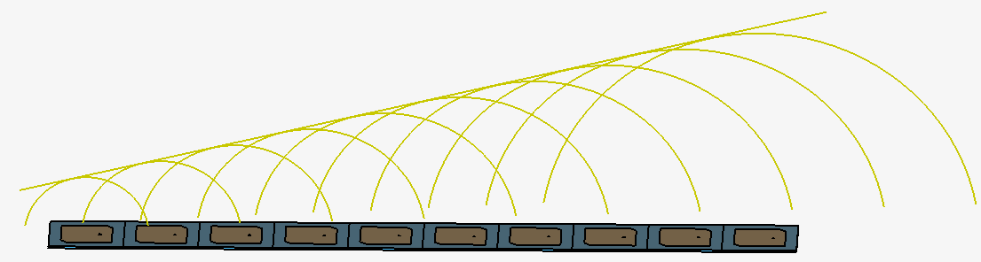
Principle of phased-array antennas explained with a one-dimensional patch-antenna array. The green circles are wavefronts of individual antennas. Due to the phase difference between neighboring antennas, the wave fronts from individual antennas form a coherent combined wave front in an oblique direction.
In this one-dimensional array, the excitations of neighboring patch antennas have a certain phase difference. The phase of a neighbor to the right is always ahead by a certain amount, and the phase of a neighbor to the left is behind by the same amount. Therefore, at a given snapshot in time, the wave front emitted by a neighbor to the right has progressed farther, and the wave front of a neighbor to the left has proceeded less far. The yellow circles illustrate this. Radiation from each individual patch expands spherically, but the spherical wavefronts together add up coherently in one direction only (provided the spacing between the antenna centers doesn’t exceed half a wavelength). The combined wavefront is illustrated by the straight yellow line. It propagates towards the upper-left in the image. In most other directions, fields from the individual patches do not add up coherently, because those fields arrive with different phases. Hence, in most other directions, the radiated power will be small.
Details: In case you need to know what the phase difference has to be to achieve a certain beam-steering angle, consider the image below.
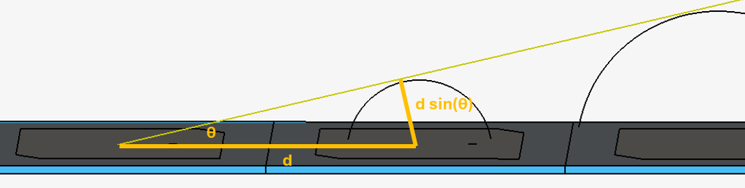
Deriving the relation between beam-steering angle and phase difference
To achieve the beam-steering angle θ, the phase difference has to be such that the spherical wavefront of a neighbor is ahead by a distance given by d×sin(θ). We first need to express this distance not in meters but in wavelength λ. The distance in wavelength is $\frac{d sin⁡(θ)}{λ}$. One wavelength corresponds to 360⁰ in phase, so $\frac{d sin⁡(θ)}{λ}$ wavelength corresponds to $\frac{d sin⁡(θ)}{λ}×360⁰$ in phase.
The phases of the individual antennas in the array can be controlled electronically with phase shifters.
Design aspects of phased-array antennas:
- Neighboring antennas have strong coupling; this influences the antenna properties. The antenna is optimized in a unit-cell model with periodic boundary conditions. See the image below.
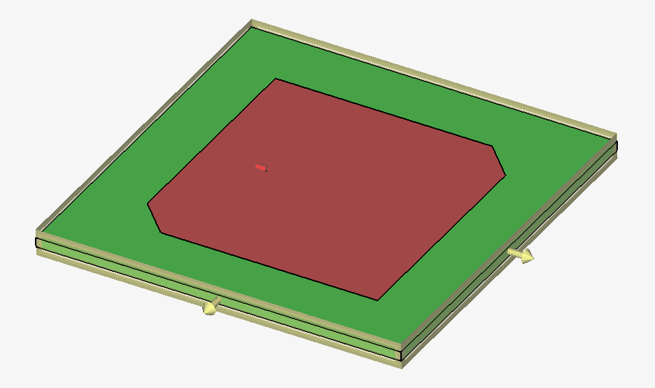
Unit cell of a patch-antenna array. The unit cell contains one antenna (patch, substrate, ground, and a source); and has two pairs of periodic boundary conditions on the four sides.
The periodic boundary conditions ensure that the single antenna behaves as if it’s surrounded by many neighbors with certain phase differences in the excitations. The antenna designer ensures that this single antenna will have a small reflection coefficient and has other desired properties. Interestingly, entire-antenna-array radiation pattern can already be generated from unit-cell results, because enough information is available from the unit-cell simulation to make predictions for a full array in a post-processing step. When doing so, the design engineer can give antennas near the edges of the array a weaker excitation. This is called amplitude tapering; it reduces the side lobes.
- In spite of the good work performed with a unit-cell model, the actual full phased array may have edge effects. This is because the unit-cell approximation assumes that each antenna in the array is surrounded by identical neighbors, which is not true at the edges. Hence, if possible, the full array should be simulated too. A simulation of a full phased array may require a lot of computer memory and simulation time.
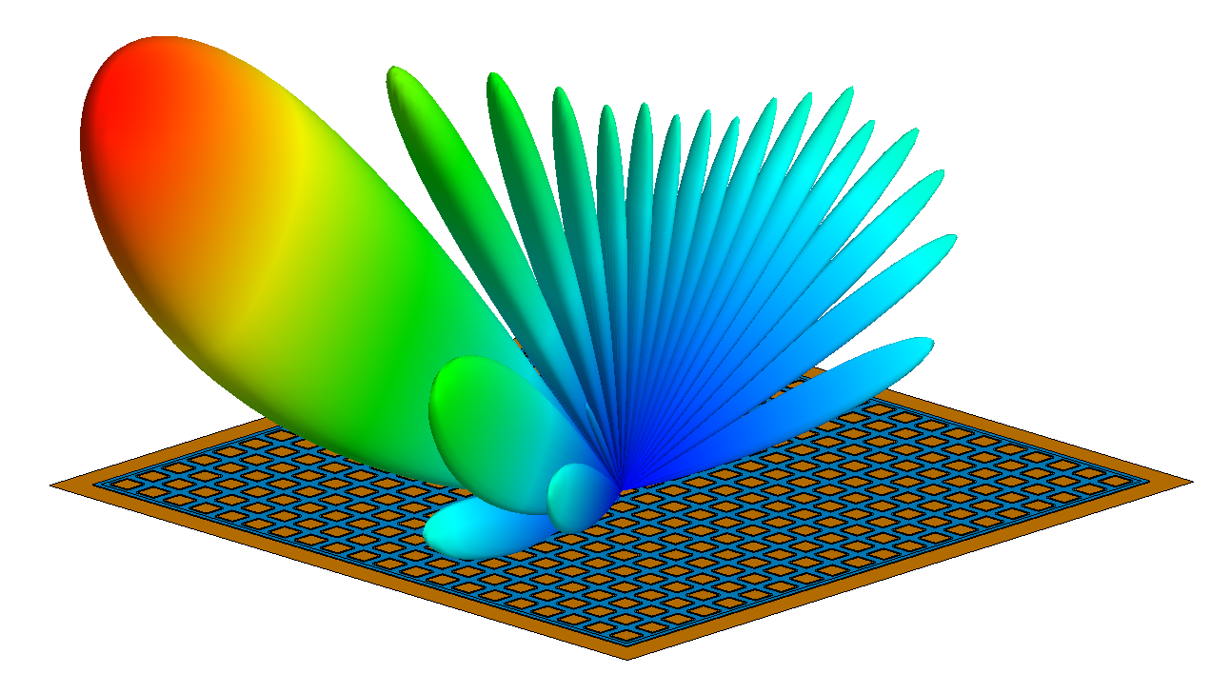
Phased antenna array consisting of 20×20 patch antennas, with the resulting antenna pattern formed by the array when scanning in a particular direction, achieved by imposing certain phase differences between individual antennas.
- A lot of geometry may have to be crammed into a small volume, especially if the antennas with their feeds have to be fancier than just patch antennas. This can be difficult to design. Furthermore, cooling becomes a problem. Remember that, in most phased-array antennas, each antenna can be no larger than half a wavelength. Otherwise, wave fronts can add up coherently in multiple directions. The resulting additional antenna beams in unwanted directions are called grating lobes.
Phased-array antennas can be found on Navy frigates and on aircraft. E.g., on the frigate in the image below, the older rotating radar antenna has been replaced by four phased-array antennas. In the image, the phased array antennas, with thousands of antennas each, are behind the gray octagonal covers (which are transparent to radar frequencies).
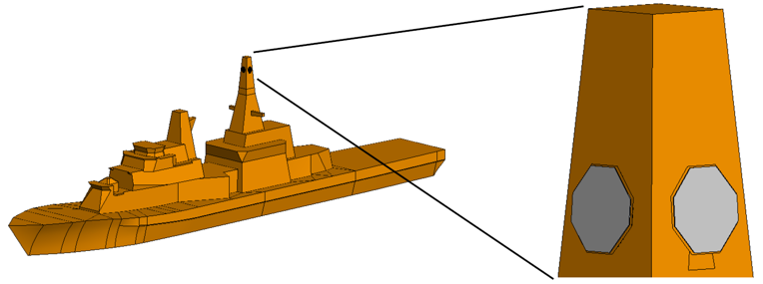
Phased array antennas on a Navy frigate. Behind each gray octagon are thousands of small individual antennas. Collectively, they form narrow steerable radar beams.
On a military aircraft, phased-array radars have been integrated into the air frame. In civilian aircraft, a phased-array antenna for satellite communication may have been placed on top of the fuselage. The 20×20 patch array, shown in an earlier image, is an example of the latter. Phased-array antennas may have to operate in multiple frequency bands, and be covered with radomes that have frequency-selective surfaces (see next section). Hence, there is still plenty of work for antenna design engineers in this area (as well as for those who design printed circuit boards to handle the incoming data and for those who work on signal processing and other supporting software).

5.10 Antenna radomes and frequency-selective surfaces
A radome is, simply speaking, a plastic antenna housing. Many antennas need a radome. It protects the antenna from the weather. Furthermore, in an airplane or a missile, where the antenna is integrated, the radome maintains the desired aerodynamic shape of the airframe. Needless to say, the radome material has to be transparent to the antenna radiation.
Although this sounds simple, plenty of work goes into radome design. The radome has to be strong enough to withstand high wind speeds and vibration during flight, as well as bird strikes during take-off and landing. On the other hand, it has to be thin for reasons of weight and transparency. A typical radome will consist of several layers of different materials. The layers of an optimized radome may have variable thicknesses over the surface area.
In radome design for antennas, the following results are of interest:
- How good is the transparency of the radome at the frequencies of interest? The transparency should be maximized, with the restrictions of structural strength. Any power that is reflected back inward may emerge in unwanted directions. That leads to the next item:
- To what extent does the presence of the radome increase the side lobes of the antenna?
- For high-power antennas: is radome heating due to dielectric losses in the “plastic” a problem?
- How much boresight error does the radome introduce? In other words, what is the change in the beam direction due to the presence of the radome? In the image below, the radome is the nose of a missile, and the antenna is part of the seeker that steers the missile to its target.
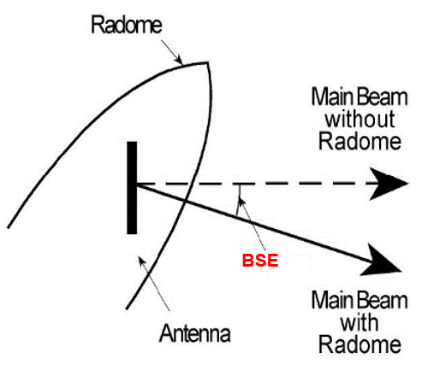
Boresight error: due to the presence of the radome, the main beam of an antenna points in a slightly different direction.
Full antenna + radome simulations can take a lot of computer memory and simulation time due to the size in terms of wavelengths. Ways to save computer resources include:
- Simulate the antenna in a separate project and import the results (e.g., a sampling of the fields near the antenna) into the radome-simulation model.
- Approximate the thick, 3D, multi-layer radome by a two-dimensional “sheet” object with similar transmission/reflection properties. This is justified if the radome is significantly thinner than a wavelength. If not, the approach might still work, but one has to make an effort to quantify how reliable the results are.
Military radomes are often covered with a frequency-selective surface (FSS). This is a periodic structure with metal shapes that have inherent filtering properties.
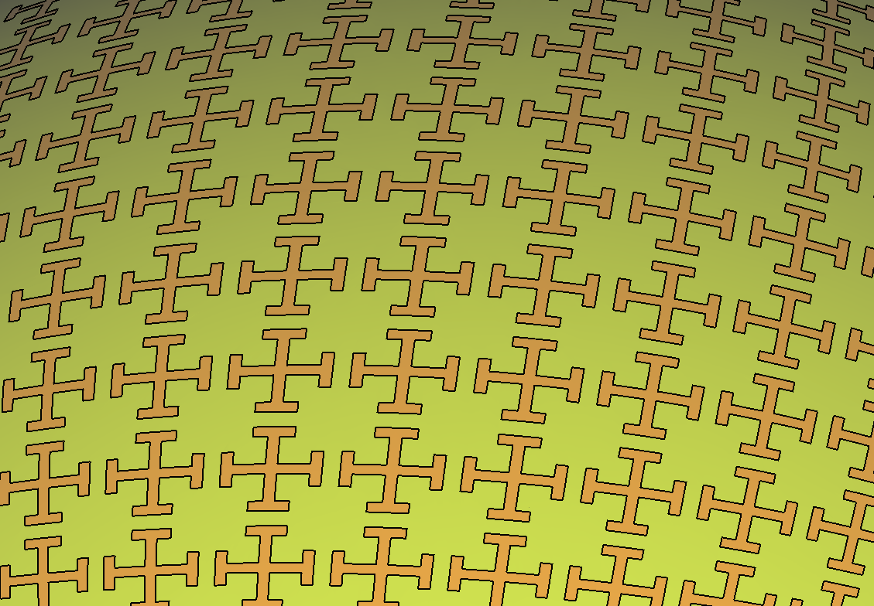
Frequency-selective surface on a curved radome. The orange shapes are thin metal; the green area is the surface of a dielectric radome.
The frequency-selective surface is designed using unit-cell simulations. An FSS has to be transparent at the operating frequency of the antenna, while opaque at other frequencies. This has several advantages:
- A jammer will have less chance to disrupt the antenna, unless it knows the right frequency to use.
- At frequencies where the radome is opaque, the radar cross section of the radome with FSS, and antenna underneath, can be lower than it would have been without the FSS.
- Interference from a nearby antenna on the same platform can be excluded.
The FSS in this image is most suited to block one frequency, e.g., to keep nearby interference at a known frequency out. The complementary structure, where the crosses are openings in a metal sheet, is most suited to allow one frequency, the frequency of the antenna underneath, to pass through.

5.11 Metamaterials
The frequency-selective surface indicates that periodic structures with a periodicity of a fraction of a wavelength can be used to create structures with interesting effects. By placing periodic structures in a dielectric material, the combined structure may behave as if it were made of a material that doesn’t exist in nature.
By placing a large periodic collection of small metal C-shaped objects called split-ring resonators in a dielectric, the combined structure may, at certain frequencies, behave as if it had a relative magnetic permeability µ_{r} ≤ 0. Similarly, metal rods in a dielectric may achieve relative dielectric permittivity ε_{r} ≤ 0. In nature, vacuum has ε_{r} = µ_{r} = 1 and any material has ε_{r} > 1 and µ_{r} > 0.999. Hence, in a metamaterial an electromagnetic wave may behave in a way that doesn’t occur in nature. For instance, a wave may diffract in an unusual direction.

A metal split-ring resonator and a metal rod. Many small objects like these, embedded in a dielectric material, can make the dielectric look as if it has unusual electromagnetic properties.
In antenna design, the inclusion of metamaterials opens up possibilities to achieve better performance with an antenna of a given size. This is, to the author’s knowledge, more a topic of academic research than of practical development.
A variation on this theme is to place periodic structures, of which the size is a fraction of a wavelength, on a metal surface. The goal is to create a surface that, macroscopically, behaves as a material that doesn’t exist in nature. The figure below shows an example of one class of such surfaces: a Sievenpiper surface.

Sievenpiper surface: an array of metal patches and vias
The entire structure is metal; the color differences are just for visibility. The structure consists of square metal patches supported by metal cylinders and mounted on a metal ground plane. Usually there is a dielectric substrate between the ground plane and the patches. As mentioned, the periodicity is a fraction of a wavelength. The structure has the interesting property that currents that would normally flow easily through the metal ground plane will, in a certain frequency band, not flow easily anymore, even if the metal is a perfect electrical conductor without any resistance!
This type of surface has a couple of useful applications.
1. Imagine two patch antennas that have to share the same metal ground plane, e.g., on a printed-circuit board. These antennas will have unwanted coupling due to currents that flow from one antenna to the other through the shared ground plane. There may be reasons why cutting the ground plane into separate parts is not an option. These unwanted coupling currents can be suppressed by placing a Sievenpiper structure between the antennas.
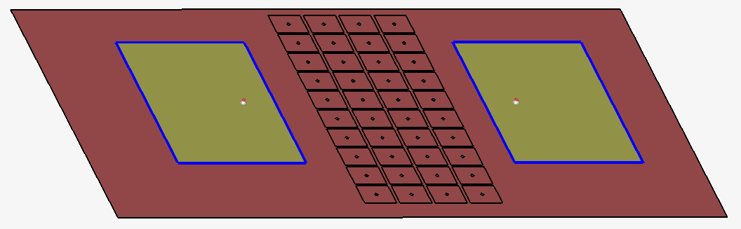
Two patch antennas with a Sievenpiper surface to suppress unwanted coupling
2. Suppose an antenna that is not a patch antenna has to be mounted parallel to a metal surface. Normally, it cannot be very close to the surface, because any electric fields produced by the antenna will cause electrons in the ground plane to move until the electric field is canceled. It is possible, though, to mount the antenna parallel and very close to a Sievenpiper surface, because the electrons in such a structure don’t move easily in a certain frequency band.
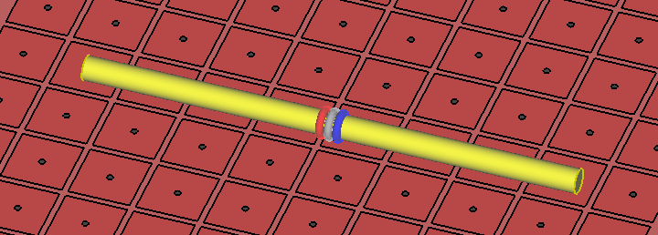
Dipole antenna close to a Sievenpiper surface. A dipole antenna won’t work near a metal surface, but can work well near a Sievenpiper surface.
In terms of boundary conditions:
- A normal ground place, which is a good electrical conductor, will not allow an electric field vector to exist along the surface, while a magnetic field vector along the conducting surface is no problem.
- The Sievenpiper surface will, at a certain frequency, not allow a magnetic field vector to exist along the surface, while an electric field is no problem. For the magnetic field, it is as if there are magnetic charges in the surface that move easily. Therefore, such a surface can be called a Perfect Magnetic Conductor. Magnetic charges (that are free to move by themselves) don’t exist in nature, and this combination of electric and magnetic boundary conditions doesn’t exist in nature. Hence, this surface (macroscopically) behaves like the surface of a material that doesn’t exist in nature.

5.12 Computational methods for antenna simulations
Chapter 9 discusses the computational methods in detail. In this section, we present just a few guidelines for antenna simulations.
The main computational methods for general-purpose, 3D, full-wave electromagnetic simulations are, in no particular order,
- The Method of Moments, possibly accelerated with the Multi-Level Fast Multipole Method;
- The Finite Element Method;
- The Finite-Difference Time-Domain Method, along with a similar method called the Finite Integration Technique.
All these methods solve the fundamental equations of electromagnetics, Maxwell’s equations, accurately. All these methods are well-suited for antenna simulations.
Simulations of phased-array antennas with thousands of antennas and simulations of reflector antennas with exceptionally large reflectors (diameter hundreds of wavelengths) might require a lot of computer memory and time. For those, the following tips apply.
If a phased-array antenna has thousands of antennas, then relatively fewer of them will be at the edges of the array. Therefore, basing the array analysis on unit-cell results (i.e., a model of one antenna “unit cell” with periodic boundary conditions) becomes more valid. If analysis of the entire array is required, and you find that you don’t have enough computer resources, you might inquire about the Domain Decomposition Method within the Finite Element Method.
If a reflector antenna is large in terms of wavelengths, then it is justified to apply an approximate method to the reflector, while continuing with a rigorous method for the feed structure. Good candidates for approximate methods are the Physical Optics method and ray-based methods.

5.13 Points to remember
Many antennas are able to radiate efficiently, or receive radiation efficiently, because they are designed to resonate at a given frequency. Examples are monopole antennas, dipole antennas and patch antennas
To enable resonances, relevant geometries often have sizes that are multiples of a quarter wavelength. A matching circuit connected to an antenna can place the resonance at other frequencies.
Antennas don’t always need a resonance. A gradual transition from a transmission line to free space will also radiate. Examples are Vivaldi antennas and horn antennas.
Phased-array antennas are formed by placing many small antennas in a regular pattern. By controlling the phase differences between the neighboring antennas, the main antenna beam can be steered electronically into a desired direction. Phased-array antennas offer advanced capabilities, both in military and civilian applications.
Phased-array antenna. The main beam has been steered electronically in the desired direction.

If you would like to access the full eBook, please fill out the form on this page and download it for free.

